Brussels 2015
As most people know, as well as running marathons, I also enjoy treading the boards in local Gilbert and Sullivan productions. In February, Christine and I were in a performance of Pirates of Penzance, where the Major-General proudly boasts “I know the Kings of England and I quote the fights historical – from Marathon to Waterloo in order categorical”.
In 2010, I completed the Athens Marathon in the 2500th anniversary year of the Battle of Marathon, so what could be more appropriate than to complete Brussels this year in the Bi-Centenary of the Battle of Waterloo? My original plan was to complete my 50th marathon on my birthday in May, but injury and illness meant that it was my 49th and also resulted in not being able to complete one over the summer. So I elected to make this my half century…. And what a place to do it!! Registration and the start are in Cinquantenaire park, created for the 50th Anniversary of Belgium becoming an independent nation….. 50’s all round!
We left Newcastle late on the Friday via BMI regional, along with only 9 other passengers. Baggage retrieval was a doddle! On the Saturday we went to registration to pick up my number and T-shirt. After Malaga, Malta and Seville, it was refreshing to visit a decent marathon exhibition for a change, with a reasonable amount of stalls. We soaked up the sun a little in the park and then visited the Military Museum which is situated within the Cinquantenaire Building. Given Belgium’s strategic positioning in warfare over the centuries, this was extremely interesting…. plus you also got the opportunity to go onto the roof of the Cinquantenaire Arch.
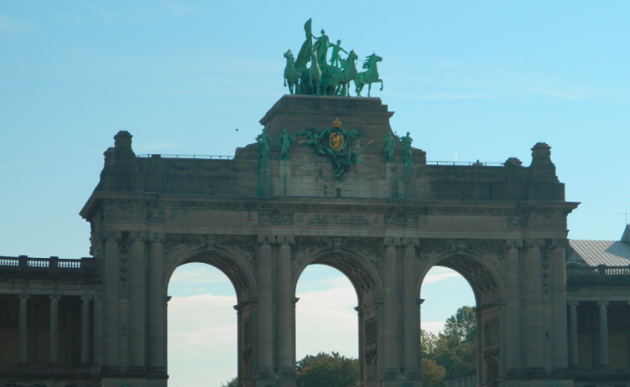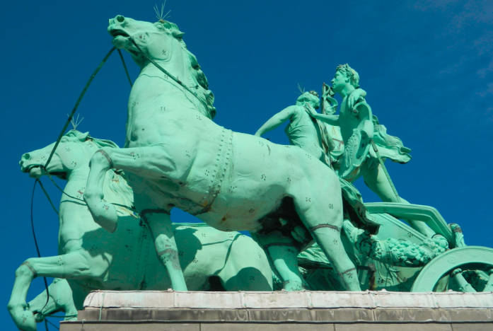
The Cinquantenaire Arch
We then went to the Grand Place – once described by Victor Hugo as the greatest square in the world. There was a band leading a dozen playing card characters through the square. We never found out what it was about, but it did create much interest.
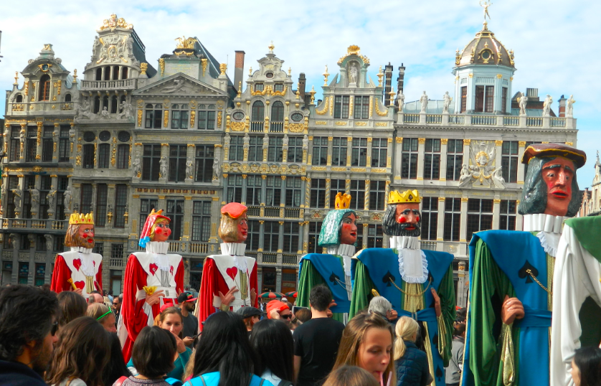
The day of the race beckoned. Transport in Brussels was very marathon friendly with the Metro stopping next to the start and the finish and well signposted on the floors of the metro stations.
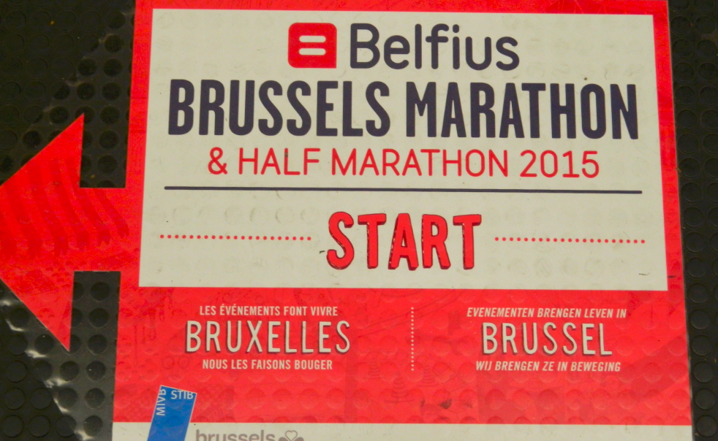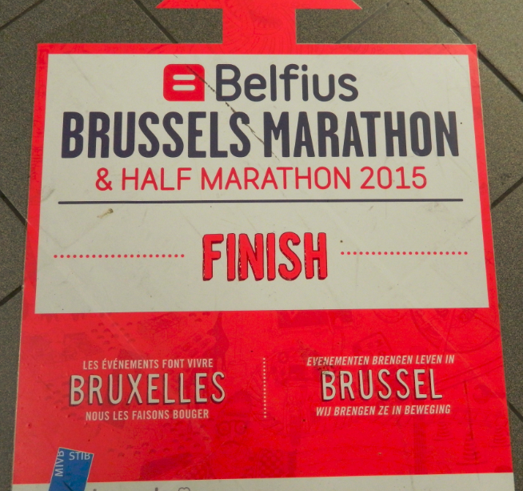
Metro Stations guiding runners and spectators to the start and finish. The balloons are waiting their guide runners and someone contemplating the start!
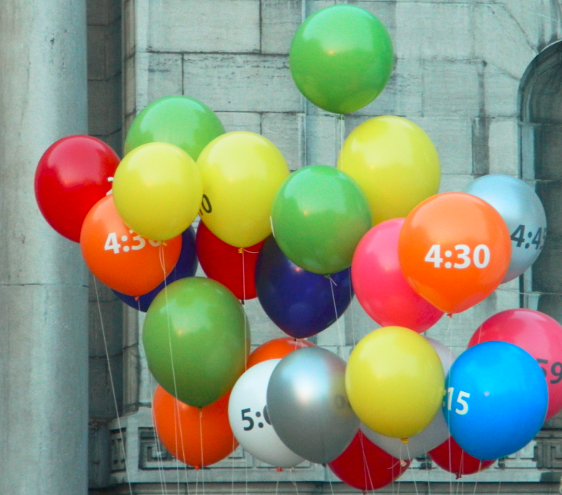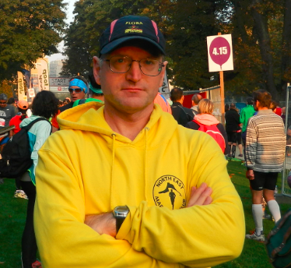The route was quite undulating with some long drawn out climbs and the knees weren’t keen on the equally long downward slopes. There is a strict 5 hour cut-off time and my last outing was 5:12 at Edinburgh…. So the pressure was on. I set myself targets of 16k in 90 minutes, 32k by 200 minutes and the rest should take care of itself. I was outside my 10 mile target by 50 seconds, hit half way in 124 and was 4 minutes outside of the 20 mile target, by which time I was feeling the strain, but still comfortable of being able to walk it if I had to! A lot of the route was out and back down a dual carriageway, but there was also a lot of parkland and lakes. There was an interesting fountain at 24k depicting an animal band and the water spouted from the instruments. Just after the 37k mark we turned onto the Boulevard towards the Cinquantenaire Gate. I’ve never done Berlin (yet!), but running through the gate just after the 38k mark was probably as close as it gets to going through the Brandenburg without actually doing so. I met up with a guy from Ypres and chatted through the final couple of kilometres. Then there was a little drag through the business district before going down the side of the Royal park, past the Cathedral and into the Grand Place at 41k. The finish is a little off the beaten track, but within 10 minutes walking distance of the hotel…. and time to sample some of Belgium’s finest beer….. but I leave the chocolates until another day.
To complete the journey, I visited Waterloo on the Monday with both my Athens and Brussels medals. I had completed my own personal “Marathon to Waterloo” and wrapped up my half century to boot.
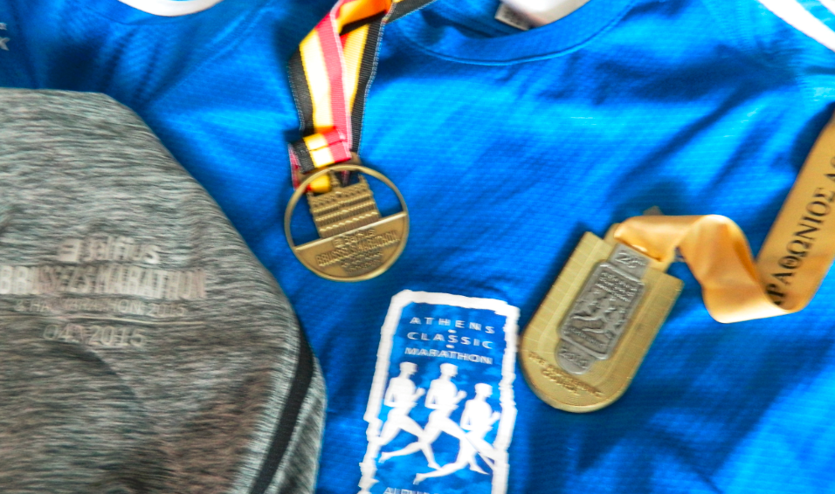
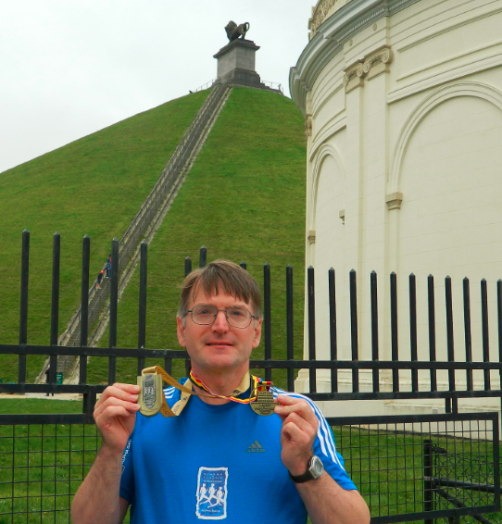
The plane was much busier on the way back with around 21 passengers.

