locality

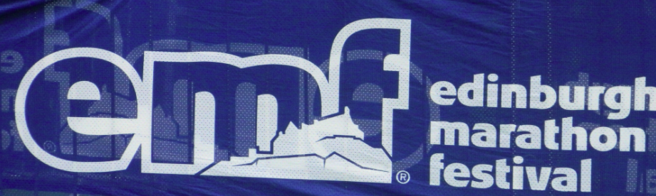

I first ran a marathon in Edinburgh way back in 1985. It was the first that I had taken part in away from Tyne & Wear. I was never to run another Tyne & Wear marathon for over quarter of a century – but that’s another story. The marathon was only run one more time (1986) before it was disbanded. In 1999 a Fife-Edinburgh marathon was run from Dunfermline to Meadowbank Stadium over the Forth Road Bridge, but due to funding issues it went down in history as a one-off. The current inception was reformed in 2003 with a little over 3000 runners. The following year the relay was introduced and the half marathon, 5K and 10K were introduced around 4 years ago, followed by the 2 junior events. There are still around 30 who have run all 12 of latest version of the event. Having missed the 2012 event, I now have to settle for associate membership of the Mile AYE (All Year’s Edinburgh) Club. The annual dinner of the Mile AYE club was held on the Friday night, where Neil Kilgour (Race Director) was the guest of honour. Neil spoke of the logistics of organizing a big city marathon with one or two statistics and costings. Road closures for the event are around £200k and the metal plates placed to support the baggage busses on the school field at the reunion area amount to £30k alone.
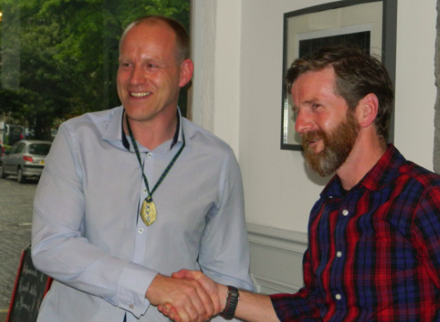
Neil (Left) with Aye Club President George Douglas
All in all, quite interesting to see the event from the organizers point of view and a complete contrast with our own club’s no frills no fuss policy, but the main event was to catch up with the other members of the club. Neil was inducted as an honorary member of the AYE Club.
Around 32000 take part in the 5 events, around 8200 complete the marathon itself. The interesting statistic is that “Edinburgh Marathon Festival” only has around 25% actually running the Edinburgh marathon!
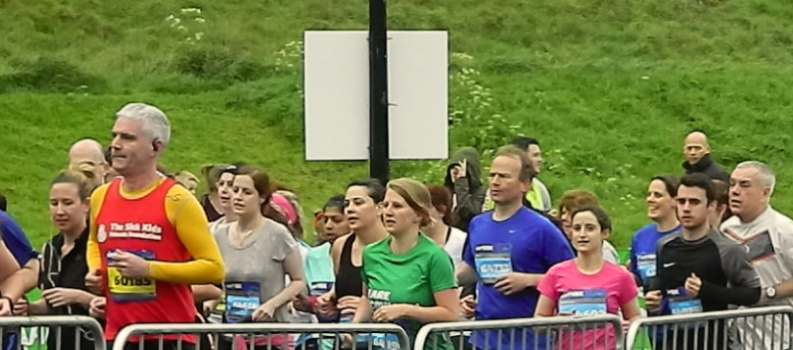
Runners start the 10k event on the Saturday morning
The next comparison with the club is the merchandise with baseball caps costing £13.50 and as for hoodies…. Makes our club kit fabulous value for money in comparison!
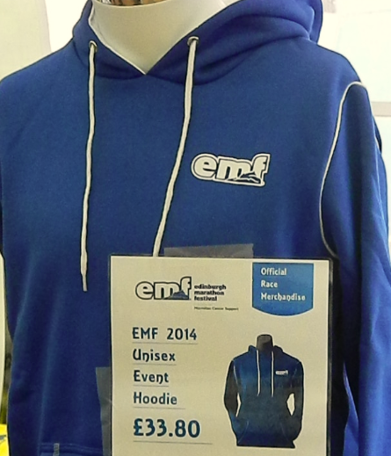
The forecast is for heavy rain, but the weather is merely overcast when the race starts at 10am and the mist of the earlier part of the day is starting to lift. The late start is to help logistics in clearing the finish area for the half marathon, before the elite field in the marathon approach the area. This has been a problem in prior years when it has been extremely hot by the time the field reaches its conclusion. No such problem this year, although the sun does get out a little during the race. One of the common complaints about the Edinburgh Marathon is that only the first few miles are actually run in Edinburgh itself. The majority of the event takes place along the East Lothian Coast taking in Portobello, Musselburgh, Prestonpans, Longniddry and turning back in the grounds of Gosford House and returning to Musselburgh.
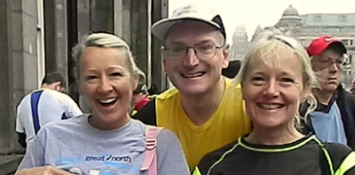
A few NEMC members had an impromptu meet up prior the event
After last year’s faux pas with the medal, this year’s medal was a lethal weapon in the shape of Edinburgh Castle. Having challenged members of the AYE club at the post run pub drink, we came to the conclusion that at no point does the marathon route give a view of the castle! The T-Shirts are yet again blue!
The logistics in returning to Edinburgh are not ideal. In the past I’ve walked to the Shuttle buses (around 20 minute walk away) and caught the bus back to Edinburgh, but these tend to drop off in Regent Road, so there is still a fair walk back to the centre. In other year’s I’ve caught the service bus which stops outside of the School grounds and takes you into the centre of Edinburgh, but goes the long way round and the traffic congestion is a nightmare. This year I learnt of a “cunning plan” from one of my “Mile AYE” friends, which is to walk to the Shuttle bus site, but continue over the bridge and catch the train into Edinburgh. It only runs once an hour on a Sunday, but only takes 12 minutes. Over the last few miles of the race, my brain is telling me what I need to do to finish, get through the finish area, pick up bags and walk to the station. It went like clockwork. Finishing at 3pm and catching the 3.41 train. Arriving at Walyford station just in time for the expected downpour. Within 70 minutes of crossing the finish line, I was back at the hotel just off the Royal Mile.
We read up about the Commonwealth exhibition at Holyrood where gifts to HM Queen from the Commonwealth were on display, along with medals and batons from prior games were on display. This was a little disappointing and the games memorabilia was restricted to one small room and the gifts were restricted to another room, but interesting all the same.
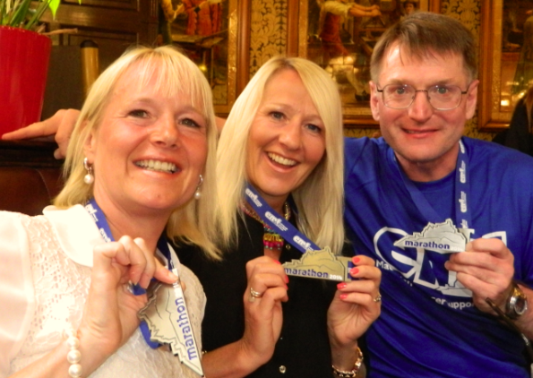
A not quite so impromptu in the Café Royal afterwards
Paul Blakey
May 2014

