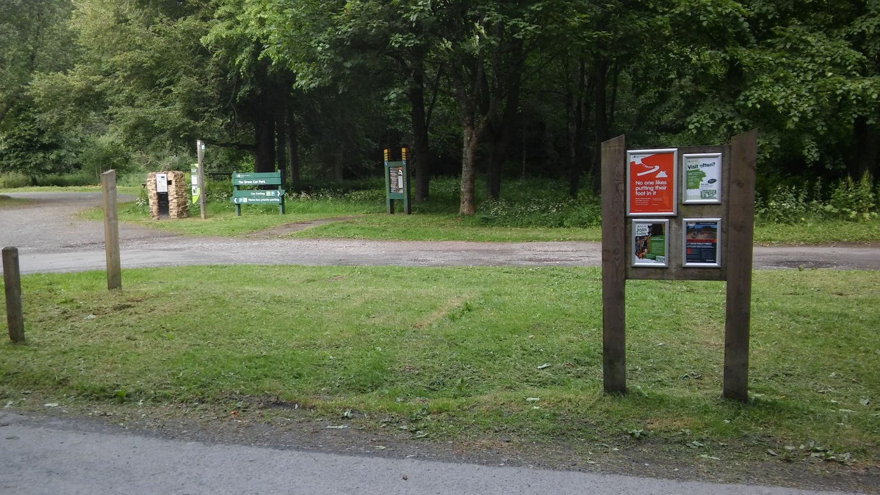
Start: 9:30 at The Grove carpark. Please park here. The start is NOT at the visitor’s centre this year. Car parking is £6 per car and there is limited space, so please car share where possible.
Registration: at the car park from 8:45 – 9:15
Toilets and water stations: 3 portable toilets at the start. You will pass these each lap. Drinks station at the start and finish area and at the top of the hill. You will pass drinks stations twice in each lap. Drinks stations will have water, juice and sweets. Chocolate and crisps will be provided at the end of the race.
First aid: This will be provided by the Mountain Rescue service.
Medals and prizes: all runners will receive a medal. Age group trophies will be awarded to the male and female winner of each age group category in both events. Please see a marshal if you think you have won one!
The route: There will be minimal signage and limited marshals on the route, but it is very simple if you follow these instructions.
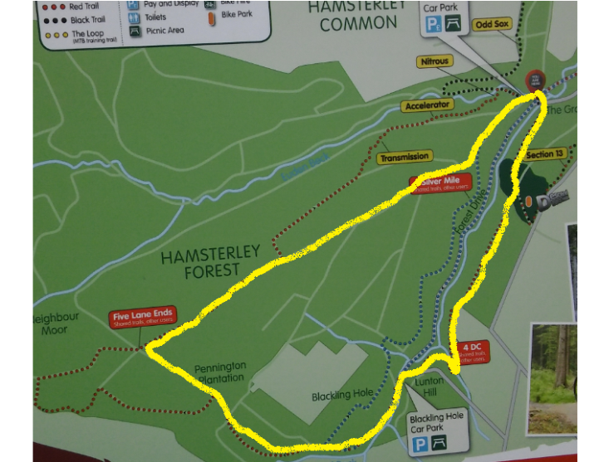
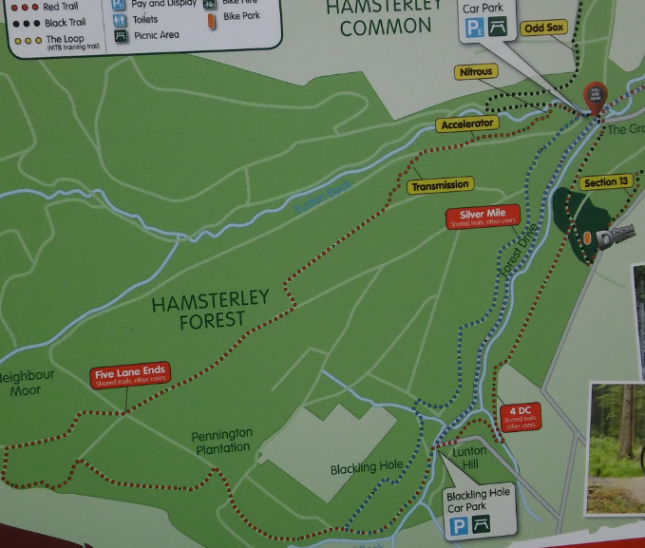
Hamsterley map and map with our route marked on.
Start: There is a short loop to begin with which ensures you will run the correct 13 or 26 mile distance. This will be explained at the race briefing.
Follow the red route signs.
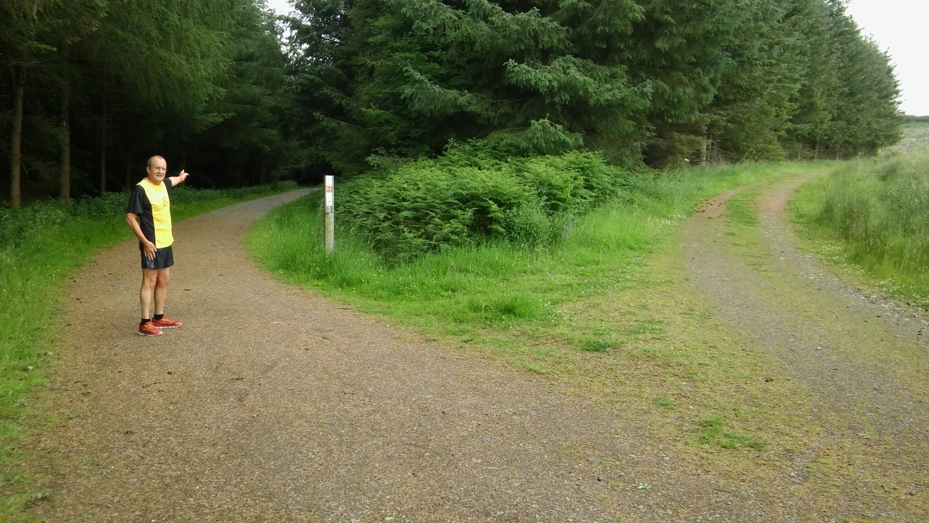
Keep to the main path. When you reach this junction, follow the route modelled by Ian.
Continue along the red route.
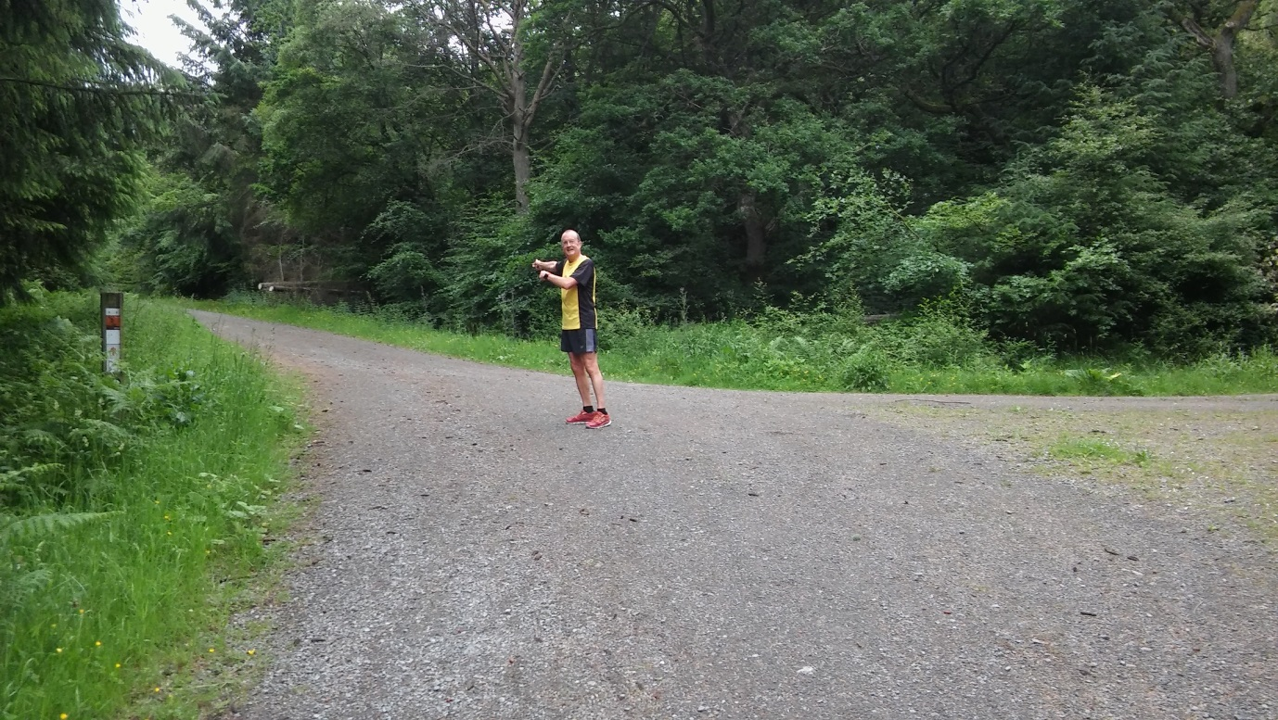
At this junction follow the route demonstrated by Ian.
Continue on the red route up a big hill until you reach this point:
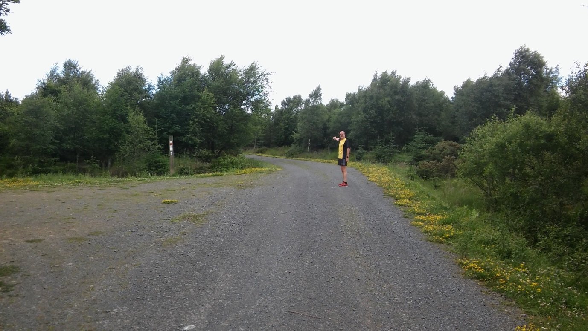
Stop following the red route and go straight ahead. Continue until you see the drinks station here:
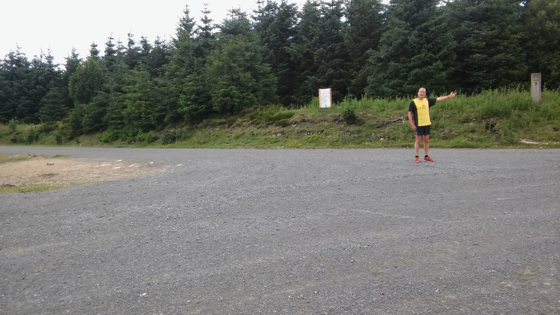
At the drinks station you will be directed to take a right and go down a lovely long hill.
When you see this junction:
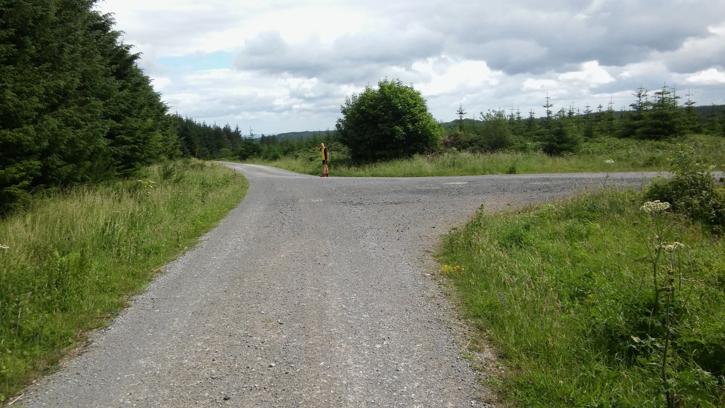
Carry on in the direction shown by Ian. Carry on down the hill.
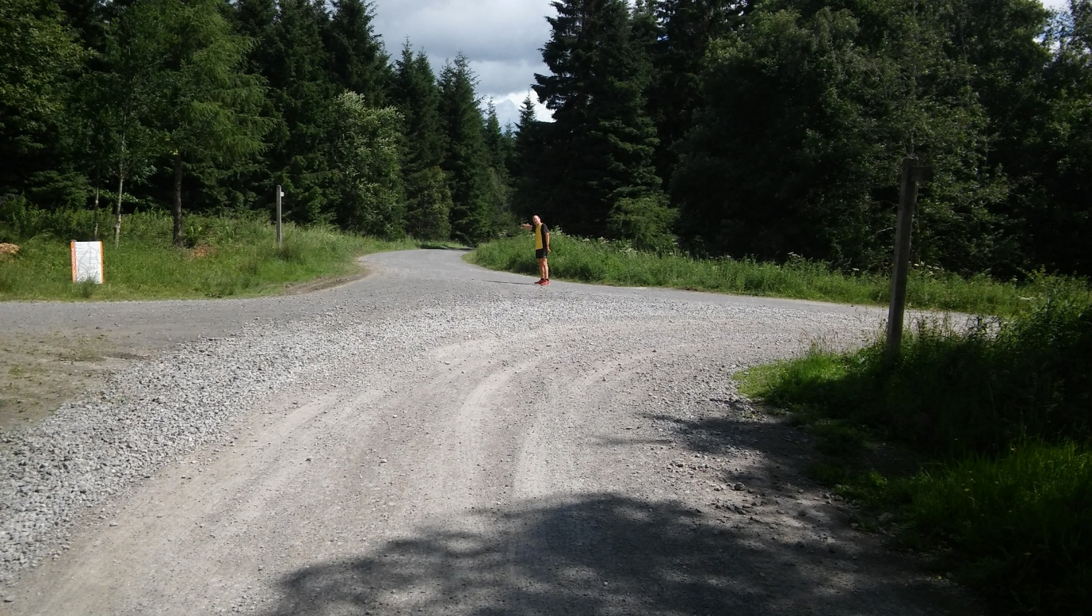
When you get to this point, carry on along the route shown by Ian. This turns left around a corner and down another hill. At the bottom of the hill, turn right and run past Grove house. This will be on your right. Follow the path around to the right and back to the start. Repeat.
We look forward to seeing you on Sunday!

