Leas Marathon 21st February 2016
Please park at Marsden Lea car park, NE34 7BS http://www.southtyneside.gov.uk/article/9100/Parking-at-South-Shields-seafront
Start just north of the Marsden Grotto Pub.
Map going south of start.
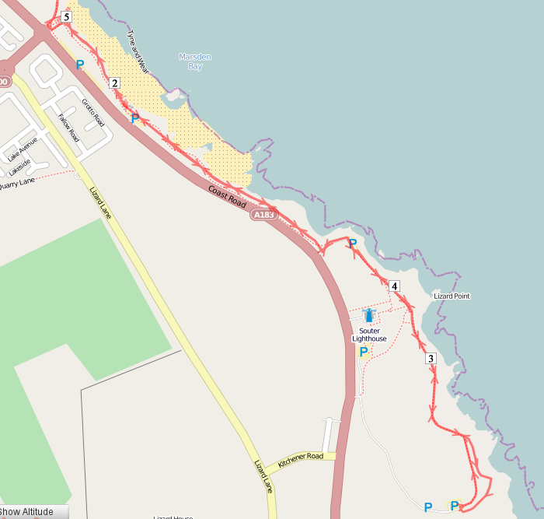
Parking
Start
Run SOUTH through the Grotto car park towards Souter Point Lighthouse following the path closest to the cliffs past marker signs 64, 65 & 66
On reaching the now closed, car park after 66, turn immediate LEFT after entrance and run coastward with fence on LEFT to resume the Coastal Path at marker 69
Continue heading south through gate to coastal side of Lighthouse, past marker 75
Take LEFT fork where paths divide at marker 82, continuing to marker 85
At 85 run up to wooden fence and run with fence on LEFT into Souter car park
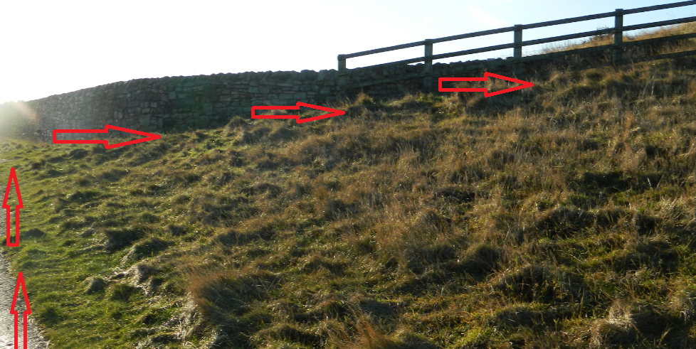
Run straight back out through gate past sign saying “Car Park closes 6pm” You will connect with path you came up on. Continue the way you came back to the start.
Map going north of the start.
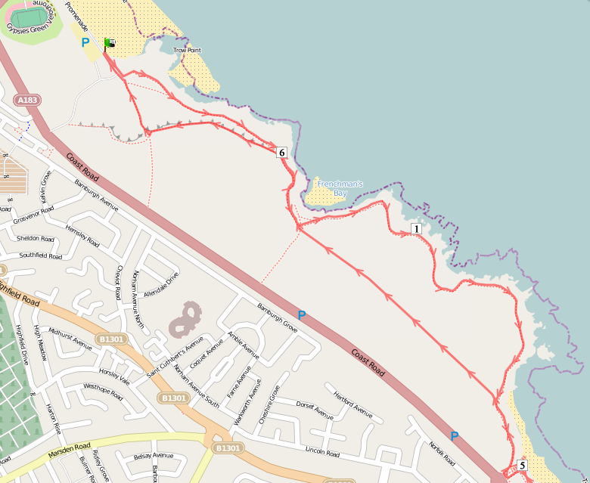
Run north past Minchellas until just after sign for Camel Island – if you reach marker 47 you have gone too far!
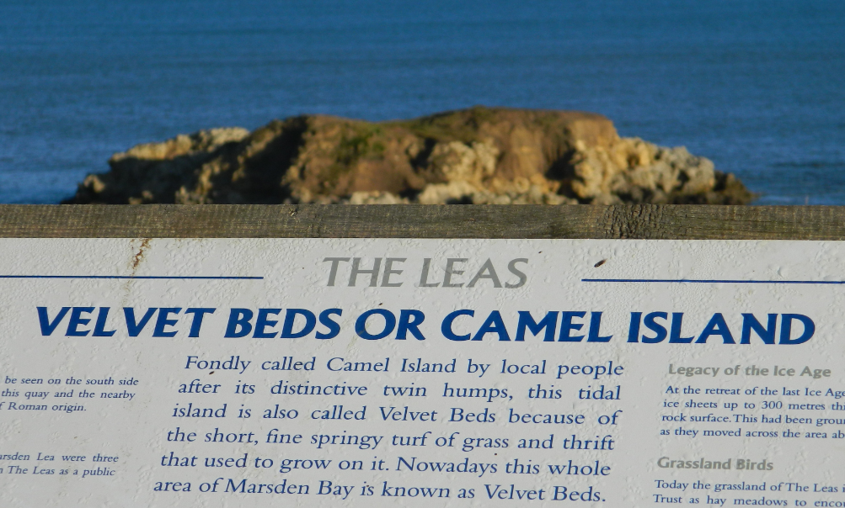
Leave yellow path here, turning LEFT and heading due NORTH on grass track with bushes on RIGHT to run through the middle of the Leas
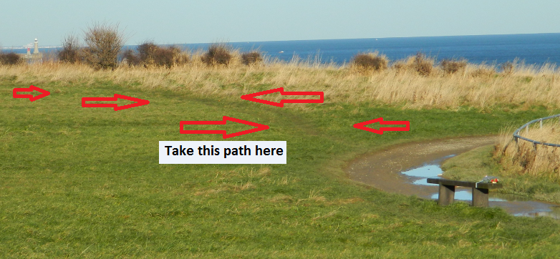
On reaching green litter (dog waste) bin turn RIGHT back on to yellow Coastal path and follow back to marker sign 25 at top of quarry
Do not go down into quarry here, turn LEFT and follow along rim of quarry to 2 more green litter bins standing together. Descend between these into the quarry until you reach Water’s Edge pub.
After a few metres, turn sharp LEFT to follow the Coastal Path sign through the Trow Rocks quarry site and on to path as it climbs gradually up to the Leas, emerging at marker sign 25
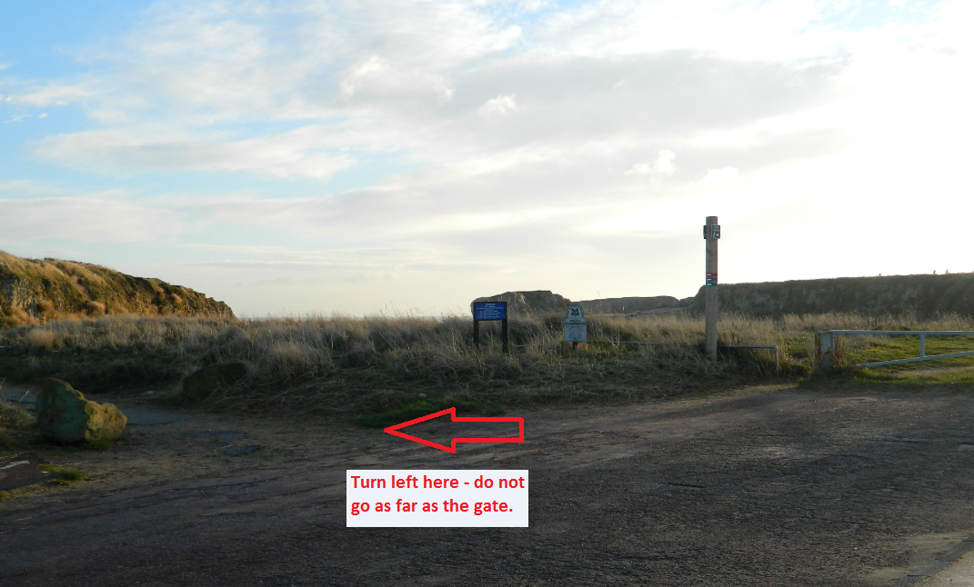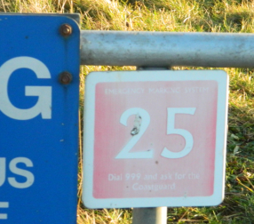
Continue for approx. 2 miles on the obvious, yellow-clay surfaced Coastal Path as it skirts the coastline towards the Marsden Grotto, (Do not deviate from path on to any of the corner-cutting, short cuts!)
The path turns to the RIGHT as it approaches the cutting down to Marsden Beach. Follow it to Minchella’s ice-cream building, across the cut and immediately back to the coast – reaching the cliffs at marker number 50.
Continue to the start and repeat up to 3 more times!

