MONTANE TRAIL 26 HOWGILLS
SUNDAY 25TH MAY 2014

I'll be honest, I didn't know very much about this run when I entered, it was a last minute decision a week before the event and I was entering mainly so I could keep my personal aim intact of completing 10 marathons / ultras in 2014 after I had discovered the Town Moor Marathon wasn't to be staged this year.
It looked a fairly tough trail marathon with some pretty big climbs but I have no problems with hills or even getting dirty so after a little more internet research I took a punt and entered.
Another bonus was that it was on the bank holiday weekend so I had the Monday off work to recover.
Having ran Windermere in the heat the week before I had no designs on a particular finishing time, it would simply be a case of going out to enjoy the day.

The start and finish point was Sedbergh, a very picturesque town in Cumbria, not far from Kirkby Stephen. This was only a 2 hour drive from Newcastle but obviously meant an early set off time. The roads were quiet early on the Sunday morning so I took a leisurely drive and arrived in good time and was swiftly ushered into a very handy parking spot with just a 5 minute walk over to the registration point.

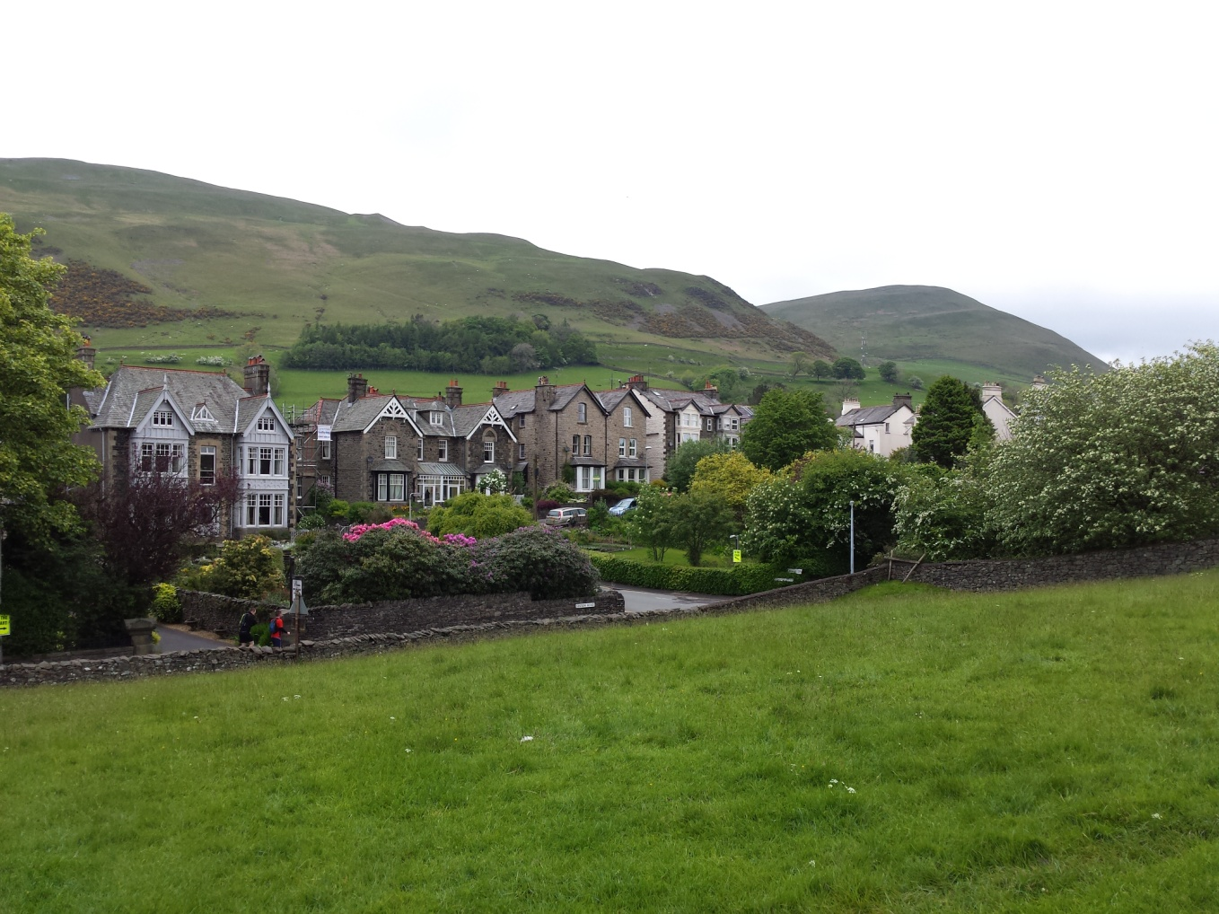

The very scenic town of Sedbergh

Registration itself was a breeze, straight in and within a minute I left with an envelope containing race number, timing chip, Montane t-shirt and a couple of goodies. As I was so close to the car I had time to take all my things back over and return before the briefing and start of the race.

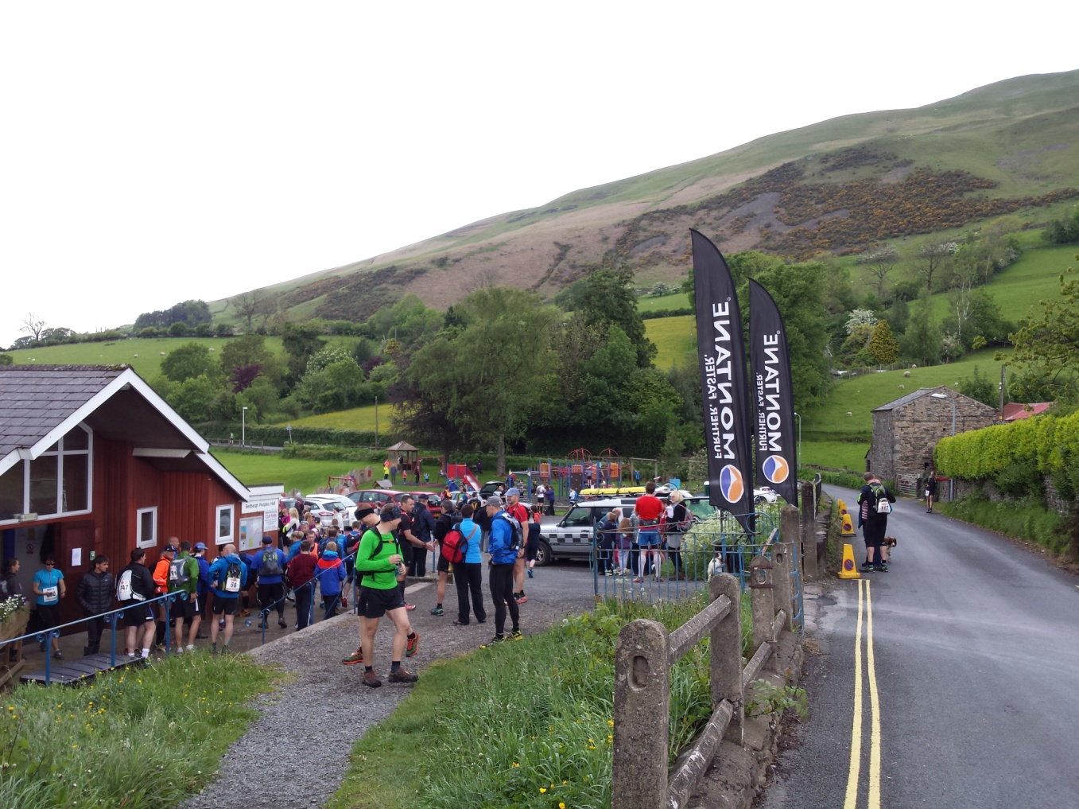

Registration and start point

The race began on time at exactly 9:40am on the local playing field, from here it followed a road slightly uphill before turning up through a farmyard and straight onto one of the biggest steepest hills you could ever wish to run (or even walk). This hill continued to climb for over a mile and a half and it's safe to say everybody, bar the front runners, was walking this section with only a handful of competitors making very brief bursts of speed as some short sections flattened out.

After this first giant climb there was a short speedy down and up over another brow before we tackled the biggest hill on the course up to the famous Calf – the highest peak of the Howgill Fells.
I can't recall seeing anyone attempting to run this section, it was very much a case on hands on knees, lean forward and get on with it.

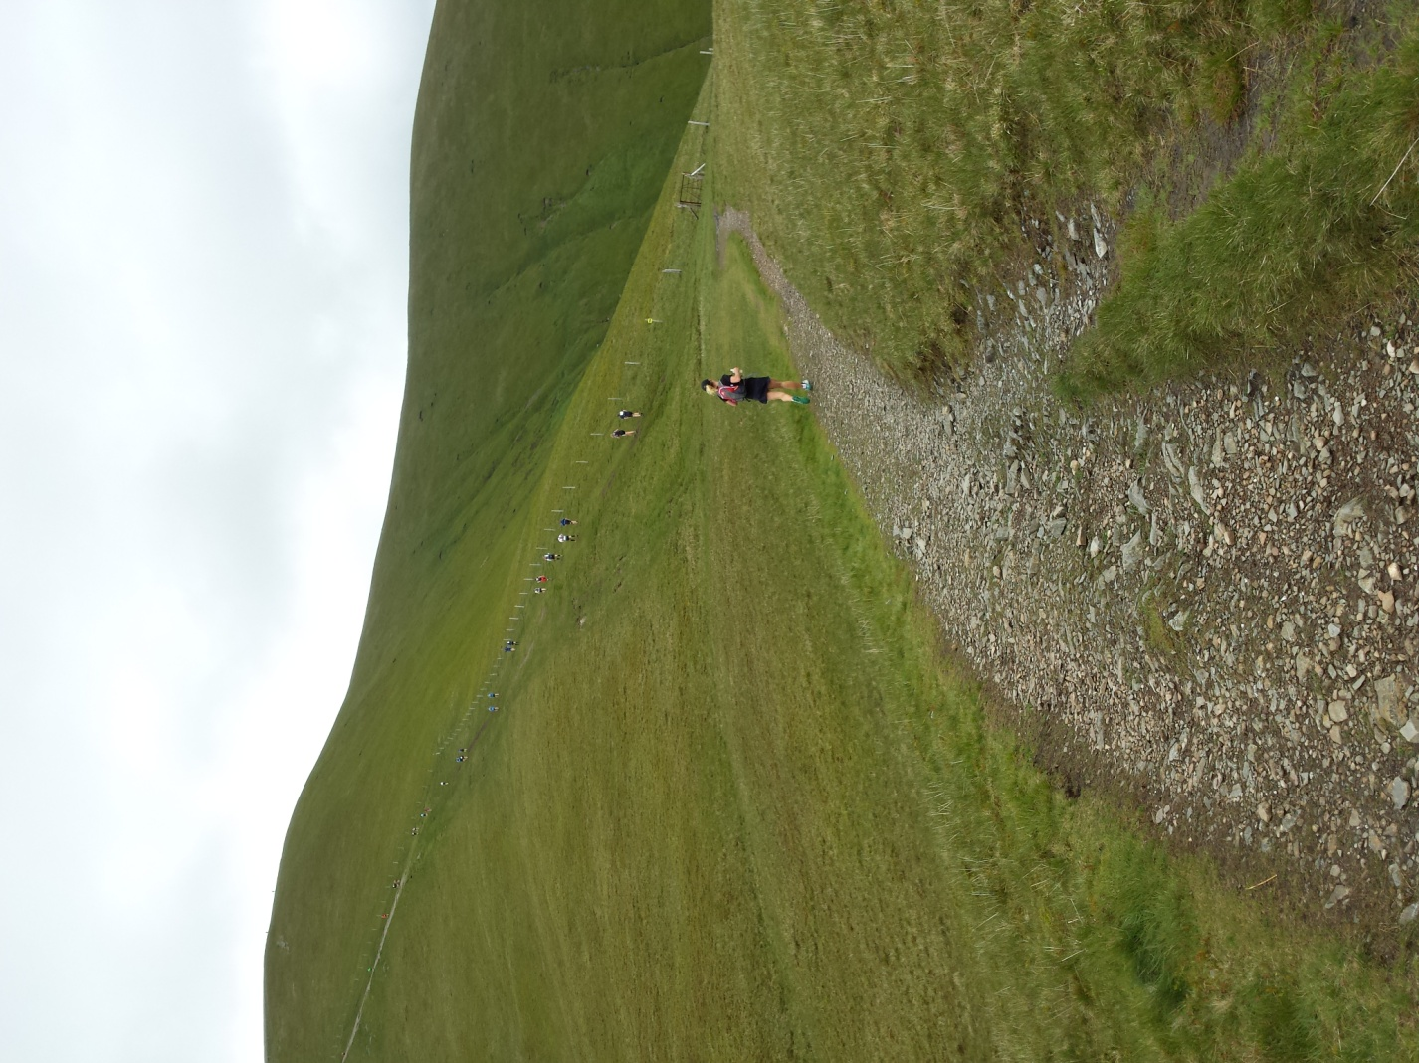
Heading up the Calf

After plenty of huffing and puffing from everyone the overall pace picked up and we finally
started to descend onto a rather technical track and it was then very much a case of keeping your
eyes on the ground ahead as the route was heavily covered with rocks and the very boggy remains of a weeks heavy rain - it was wet, muddy and very slippy.

Naturally I slipped twice but continued on at a decent pace through this section almost losing my shoes on more than occasion in the numerous muddy bogs.
It was one of those courses where you try for as long as you can to avoid the pools and mud but in the end you just go straight through them, once you're wet and filthy it doesn't seem to matter any more....

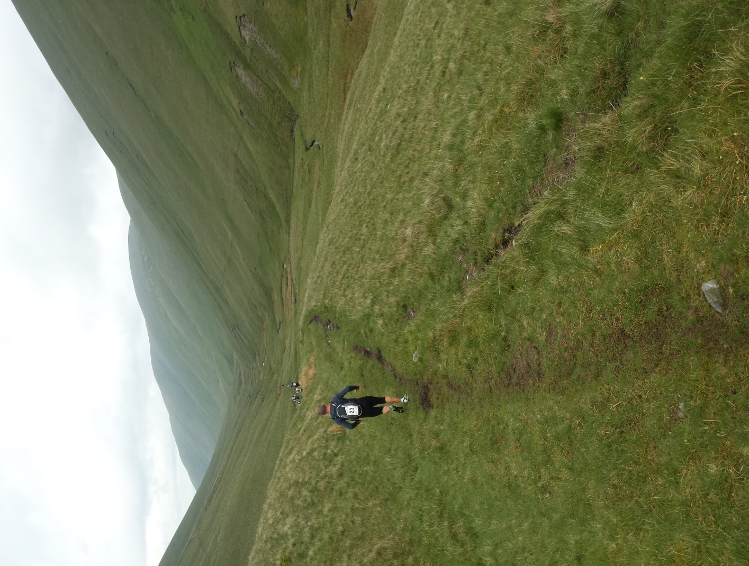
Epic scenery through the fells

Mile 9 gave way to a nice but brief gentle downhill, the rocks had gone and the soft moorland was a welcome relief. From here there was a brief road section followed by another boggy marsh which led us onto a longer road section. This was quite undulating and provided some decent short uphill walking opportunities (“breathers”) as the clouds began to clear and the sun even made a very welcome appearance.

A couple of fields and short road section later we hit the first feed station at Ravenstonedale at 14 miles. I'd have expected to see one a little sooner but what we did find was well worth the wait – a fully stocked table with various drinks, biscuits, cakes, sweets, bags of crisps and plenty more.
The marshalls here were very friendly indeed and were offering us all to take full bags of whatever we wanted, I was very impressed.
From here the road took us uphill and out the village, with several locals shouting support as we passed.
Another sharply underlating road section eventually led us down to further fields and more boggy conditions. The mud was once again way up past my ankles and once this was negotiated it was downhill through a short forest and eventually onto more rocky tracks.
After cutting through another farmyard and wading across a stream we followed the route through to the second feed station dead on mile 20. Again this was an equally well stocked tent manned by three very helpful and encouraging marshalls, this tent even had packets of salt to put in your drinks to help with cramp - they had pretty much thought of everything.

From here on it was only a few more miles so I adopted my Ultra strategy and walked anything resembling a sizeable hill and ran everything else. The rain had now started to fall but it wasn’t particularly heavy, everyone would have been wet and filthy from the route so far anyway so it certainly didn't take anything away from the enjoyment of the course.
With about 4 miles to go the terrain had become noticeably flatter and there was some very nice grassy sections running alongside a river which made for some pleasant running and I was able to keep moving at a comfortable pace despite the increasing amount of gates and stiles. I did manage however to miss a sign and I ended up running around some cottages and ending up in one of the residents gardens! Annoyingly I had to backtrack to find the correct route and when I did I then realised the pack that had been chasing me down for a few miles without any previous success had now got ahead of me.

With only a mile or two to go I got my head down and pushed on and clawed back a few places, unsure of exactly what was left to complete. Being the course it was I wasn't in any way shocked to come around a corner with about a half mile to go to find a sharp straight uphill. Once this was out of the way it was one final downhill on the main road and the finish line was then in sight below us to our right.
As has become customary I had some unwanted company approaching this final few hundred yards but a quick burst of speed on the finishing straight saw me finish comfortably ahead.

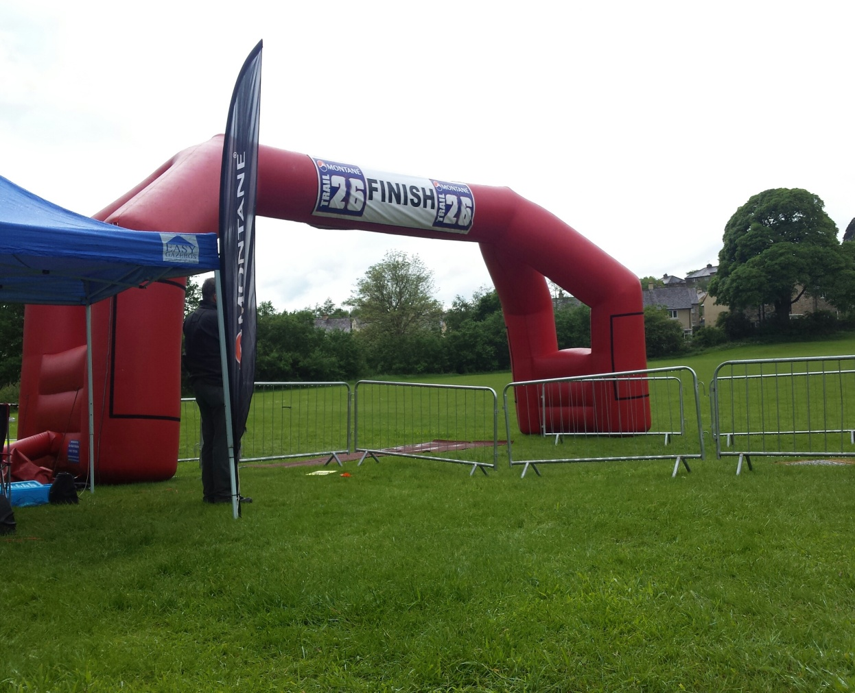

At the finish we were handed a very nice medal and then it was straight back into the clubhouse for a free hog roast sandwich which was included as part of the entry fee.
There were even free showers available too if you wanted to take advantage of them.
It was then back over to the car park for a quick warm down and change before heading home, the
rain was really starting to fall very heavy now so I was pleased to be finished but did spare a thought
for those still out on the course.

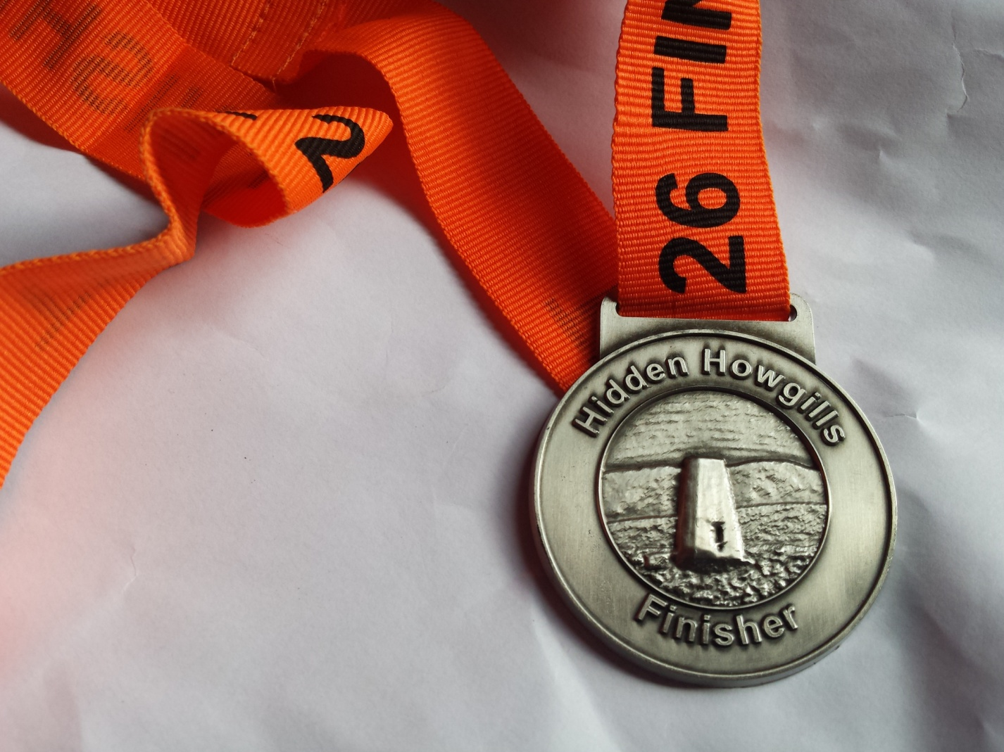

A very attractive finishers medal !

Overall I found this a fantastic day out, the views were stunning, the route was challenging and incredibly well marked, all the staff and marshalls were as friendly as you could ask for, and in terms of value for money I don't think you'd find much better, the entry fee was just 30 pounds.

If you like a challenging course and don’t mind some very steep hills and getting a little bit dirty then I would wholeheartedly recommend this one to anyone - a great trail run very well organised.

Safe to say I’ll be back next year!

Keith Robson
May 2014

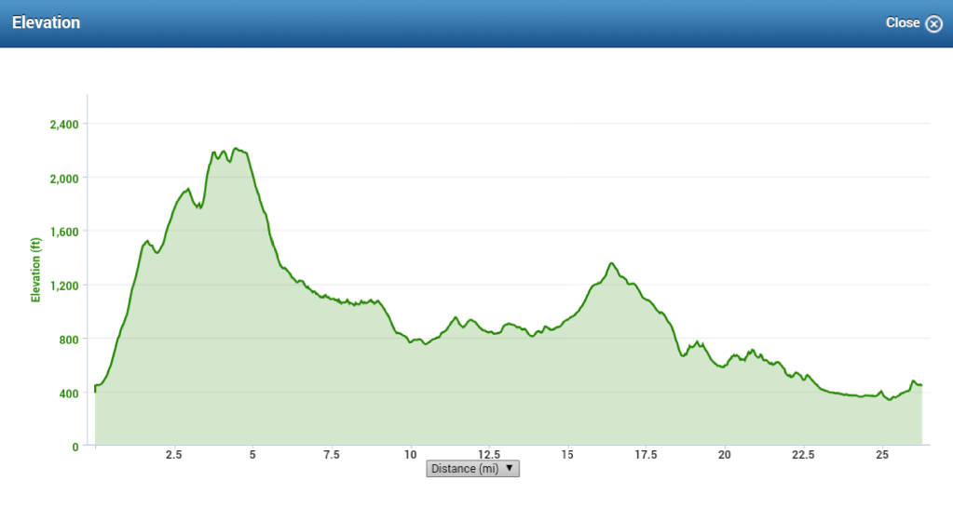
The course elevation as recorded by my Garmin

