Meadows Marathon
8th March 2015
As part of my target to run my 50th Marathon on my birthday, I needed to fit an extra one into my schedule. It was always going to be a big ask as I’d only completed Malta 2 weeks earlier and had the Leas to look forward to in 2 weeks time. I still don’t rank myself in with the hardened runners who are able to run a marathon every week and until 2013, I had never done more than three a year and here I am on the middle leg of 3 in 4 weeks!
14 laps of the Meadows in Edinburgh seemed a reasonable enough ask, but the wind and rain didn’t lend itself to running or spectating. Nor did the cobbles, and tight turns into and out of George Square which had to be negotiated at the end of each lap. Personally I’d rather have done 15 (or however many) pure laps of the Meadows than put up with the unnecessary climb up to George Square and those cobbles.
I arrived 15 minutes after registration started to find no queue. Malta take note! Although, as the race starting time approached the queue increased. There was a 5k, 10k, half marathon and full marathon, but the way that it had been planned was that no more than two events would be on at the same time. The 10k started at 10am, with the marathon starting 2 minutes later. The 5k started at 12 noon and the half marathon at 1.15.

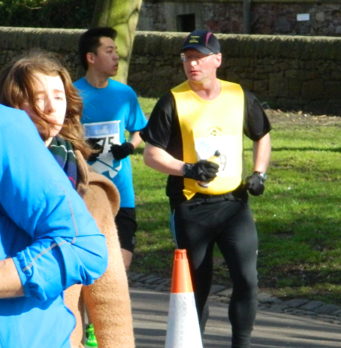
After the fun of the walkathon at Malta, I’m starting to think that multi-events are not for me. The 10k was fine most of them had gone off at a reasonable pace, but the leading runners soon zapped past on their final lap as I was only on my 3rd. I’m conscious that I’m taking up the running line and they’re trying to get good times. At 12 noon I’m completing my 6th lap when the 5k goes off. Whoosh! the front runners fly past me as I try to keep out of the road. Fortunately they turn left at the end of George Square and I have to go right to do a small loop.
Around 4 laps later the half goes off, but fortunately I’m a little bit behind them on the lap and don’t have to worry about getting in their way.

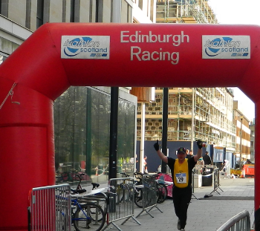
The marshals were fantastic, most of which appeared to be Edinburgh University students and they had enough for them to only be there for half of the time, but they were well organised and spent the day being cheerleaders to all on the run. The weather is unpleasant, but that doesn’t deter them from putting on their smiley faces, even though you can see deep down that they are feeling it too.

To my surprise I find myself entering into George Square with the opportunity to knock over a minute off my Maltese time. Mission accomplished. The Leas and Druridge are still to follow, but all being well, bring on Edinburgh (again)!

