Malaga Marathon 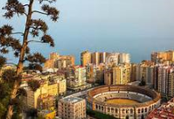
It seemed like a good idea at the time… to organise a club trip to an overseas marathon. Well it sounded like a good idea when we talked about it at the committee meeting in May. Barcelona and Malaga were mentioned and the decision was to go with Malaga. Jim was already committed as it was the annual 100 marathon club end of year finale. As social secretary, I too joined the “team”.
I have fond memories of Malaga, without actually knowing an awful lot about it. On a school cruise in 1976, we docked there, but spent the day in Granada. Something that I repeated four years ago on another cruise, only this time Christine was with me. We’ve also flown into Malaga a couple of times en route to Seville. But as for Malaga itself, there is still quite a bit to discover.
So this time Christine and I are going to Malaga and are actually staying there for me to do the marathon. Christine has other agendas and comes with the Christmas present list. We meet Jim in the departure lounge, albeit rather briefly before taking our seats on the plane. We both end up sitting close to other runners heading for Malaga. A short train journey takes us into the city centre. So short that it’s much quicker than I remembered and ended up missing the station. So we stay on the train and go back up the line, having said our farewells to Jim.

Registration

Registration was at the Palacio de Deportes Jose Maria Martin Carpena, which wasn’t a million miles from the airport, but as it didn’t open until 4pm, we needed to make a separate journey. Fortunately we were able to get a bus from outside the hotel to within walking distance of registration. We arrived at 4pm along with a number of other runners waiting for it to open – there was great amusement as they tried to erect a finishing style gantry, which fell over a few times and then one or two climbed walls to tie it to the drainpipes.
Registration was fairly straight forward, but the exhibition wasn’t really worth the journey. On our way out the inflatable gantry had fallen over, so we negotiated our way around it and got the bus back into town and strolled along the prom having a quick look at the Christmas Market.
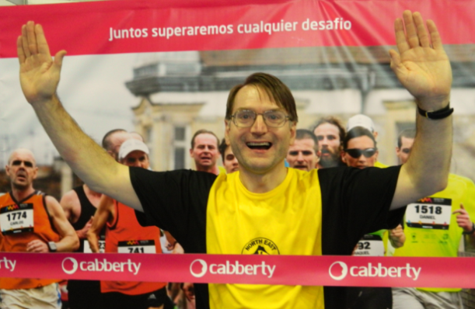
Malaga was well adorned with Christmas trees, sculptures and lights as the countdown to the Nativity was under way.
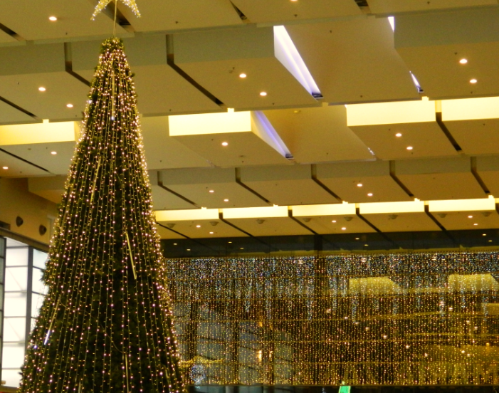
The town seemed full of Poinsettia displays. I have a unique skill of killing poinsettias. I’m sure if I they asked me to look after them I could have transformed the place from deep red to shriveled brown within half an hour.
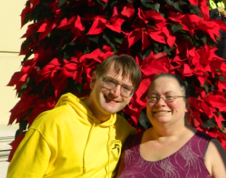
We spent the Saturday, strolling round the town taking in a couple of sites and putting a big dent in the Christmas shopping list.

The Race
People who know me will know that I’m not a great fan of mobile phones. Until July, I didn’t possess one, but for the Commonwealth Games it was a necessity. So I set the alarm off on the phone for 4.30 to grab breakfast and then reset it for 6.00 to get up. We lounge around watching the news when I look at my watch. Its 7.30 – the phone is still set to UK time and instead of allowing 4 hours for breakfast to digest, I’ve only allowed 3. The temperature is warm enough to walk to the start line in my kit. No extra T-shirts are required.
The race itself wasn’t particularly noteworthy. We very quickly make it to the coast and have a 6k run north east which is followed by a return leg down the opposite side of the road. We then hit the Bullring (not literally of course) and make our way through the port area and along the coast to where registration was held. A number of twists and turns bring us back to the River, which we cross and head out of town for around 4.5k cross another bridge and head back down the other side via the football ground and cross another bridge back into the centre at 39 k. Then comes the interesting part, we zig zag through a few of the city squares - the crowds are in full force. We pass the Cathedral and the Roman Temple before ending in the Paseo de Parques. An Italian lady catches me up with around 2k to go. "We finish together?" she says. Okay I reply and she pulls me through to a sub 5.15 finish. A quick meet up with 100 marathon club members and a few other Brits over a complimentary beer from the sponsors (well it would be rude not to) and it’s time to head back for a well-earned rest. Sadly there aren’t enough “finishers T-shirts”, so it’s a queue to leave your name, number and address and hopefully one will arrive in due course. Fortunately, I’ve got a competitors T-shirt that we all received at registration.

THE VERDICT

A good end to the season, my 45th marathon completed and still on target to complete my 50th on my birthday (touch wood). Whilst this was intended to be a club trip, with the club paying our entry fee, neither Jim nor I felt it appropriate to claim this back. Jim had already signed up and it’s not really a club trip with only one committee member taking part.
Plus points, you can’t get much better weather in December for running a marathon. 20 degrees, with a slight breeze, but nothing too problematic. There was a good atmosphere in the central parts of the race and the camaraderie amongst the UK contingent was great…. Especially after the race when everyone stayed to support the stragglers (ie Me!!)
Minus points. Too many zig zigs. It wasn’t as flat as the website suggested, but there wasn’t anything too hilly. Whilst the course was traffic free, it wasn’t unusual to be running down the middle of the road with traffic jams on either side of you going nowhere, but emitting sufficient fumes to be a little annoying. It emerged the following day that the zig-zags had proved to be costly. 27 entrants including the first and second female entrants had been disqualified for taking the wrong route. Cutting a zig zag had meant that they had run a km short. There were times that I had to gesture to a marshal which way to go. Sadly these athletes had been misdirected. Despite the fact that the leading three female athletes had individual “lead cycles” (as demonstrated in photo below) accompanying them.
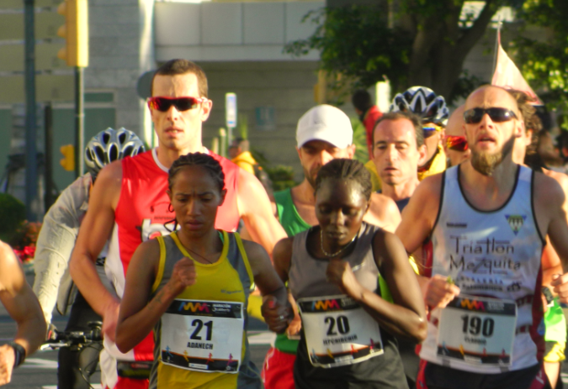

Paul Blakey – December 2014

