Pieces of Eight Marathon – Penshaw – 14 June 2015.

I have no idea why it is called that. I forgot to ask.
The important thing is that it starts and finishes at Penshaw monument.
There were three distances. 10k starting at 9:15, half marathon at 9 and the full marathon, being two laps of the half course, at 8a.m.
We met at the rangers building in Herrington Park across the road from the moument.
It was cold, wet and windy and really quite unpleasant.
The separate start times meant that the few hardy souls who had entered the full marathon had no issues registering and picking up our goody bags.
And they were. Included was an eye-searingly bright green T shirt featuring the Trail Outlaws logo, a Buff (actually a Morf, but the same sort of thing), a mini Mars bar and some bits of paper.
The NEMC was also represented by Gary, who seemed rather more cheerful about the whole thing than I was.
As start time neared, I put on my windproof jacket, hat and gloves and lined up at the base of the path going up to the monument.
The start took us straight up the hill, veering right to go around the monument itself, before a gravity defying downhill on the other side, with steps cut into the hillside.
Then it was over a stile and down across a field, then repeat. Ever downwards to the river.
We skirted the river for a short distance, then crossed it to the first checkpoint, which was also one of the few water stations.
After a pleasant lap of the James Steel Park, we were back at the drinks station before heading off into uncharted territory. In fact, it started on lovely trails through parts of Washington Wetlands Centre.
We then dropped down to the river Wear, where the overnight, and current, rain had made the very narrow trail a bit awkward. It was already on a bit of a camber and the sight of the river below made me rather cautious.
This section was son over and we were back onto good running surface.
We paralleled the A1231 for a while, with the Nissan plant on the other side.
After this was the Scania plant, then back through the Wetlands Centre, where the half marathoners were starting to come the other way.
This took us back to the drinks station at around 8 miles.
Crossing the river, I made my mistake. The 10k runners were coming from the right. I joined them and after a couple of hundred yards, by the Oddfellows Arms, there was a white backed arrow pointing straight ahead, and a yellow backed one pointing right, up the hill. I had thought the course were different and followed the yellow arrow up a very steep road, turning left onto a cinder type trail at the top. This met the course proper and seemed a similar distance from my viewing of the statistics later. I then ran with the 10k runners up a hill, along a nice flat cycle track and then back up the fields and over the stiles that we had started on.
Just before the monument, the shorter distance runners were led straight up to it, and the full runners were led around it.
It is perhaps worth pointing out at that there were sufficiently few full runners, that I as on my own for a lot, hence the navigational error.
After rounding the monument, it was back off down the steep steps for lap two, with 10k runners dragging themselves up as I was going down.
The rain had stopped by this time and it was quite pleasant, although the tricky part near the river was more slippy and churned up the second time around.
I had no navigational issues this time and there were also plenty of very cheerful and supportive volunteers around most of the course.
At the drinks station I checked my understanding of what I should have done at the Oddfellows Arms and learnt the error of my ways. There were two other runners at the drinks station at this time, who were keen to let me know as well!
We set off together and I now followed the correct route.
As I mentioned earlier, it was a roughly similar distance to my route in lap one, but rather harder, with a long river edge stretch, culminating in a lung bursting climb up steps to join the trail that I has used in lap one.
After that, and having left the other two behind, it was just head down and get to the end.
The final climbs were quite brutal and approaching the finish up steep steps was as hard an end to an event as I can recall.
I was presented with a nice medal and made my way back to the rangers hut. This was done rather gingerly as my quads were threatening to explode from my legs and my inner thighs were quite amazingly chafed. I don’t know why as I had run in the same shorts in much worse conditions before, with no issues.
At the hut (actually quite a nice building) I picked up a bottle of water and a banana and found out that Gary had finished as 1st M40, and that I was 1st M50. Hooray for us!
So that was a trophy to bring home too.
Despite the weather, this was a splendid event with a good, well thought out course and plenty of marshals.
I would certainly recommend it and hope it gets more entrants, and better weather, next year.

Ian Richardson
15 June 2015.

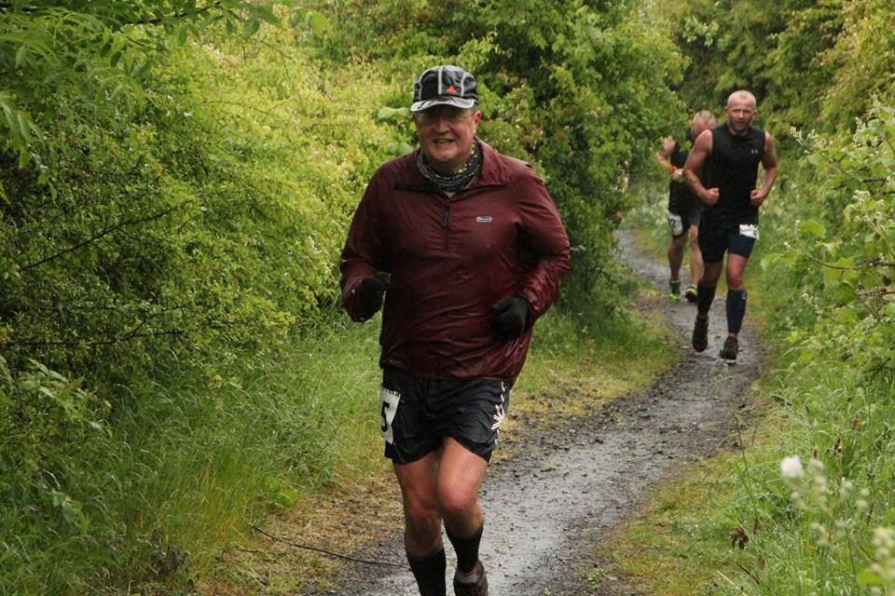

Oh, to be in England in the Summetime!

