Kielder Dark Skies – 26 March 2016.
I have run around Kielder in both directions and from four different starting locations. I’ve done a 50k version that hardly used the Lakeside Way.
However, I have never run around it in the dark, and in fact never done an evening marathon or any event requiring a headtorch.
With this in mind, Melanie and I made our way to the Hawkhirst Scout camp on Saturday afternoon, with the weather becoming more miserable the further west we travelled.
After parking by the side of the road, we made our way through the rain to the enticingly named “activity room” for a very simple and straightforward registration, including the collection of the event T shirt.
There were just over 250 entrants and most seemed to be in this room, as it was warm and dry.
It wasn’t easy to recognise people in the crowd and the vast amount of raingear, but there was a good turnout of NEMC members.
With apologies to anyone I miss, there were Adrian and Barry, Adrian B, Chris S, Andrew D, Tricia C, Sue J, and the seaside trio of Davina, Adele and Julie.
Eventually we had to be herded out into the rain for an inaudible pre race briefing.
I was surprised by how many people already had their head torches in place, given that they would not be needed for another two hours.
Barry told me it was to save time later. It’s a headtorch, Barry, not the lighting rig for Glastonbury!
Astonishingly, we were sent on our way five minutes before the scheduled start of 5p.m.. This is much to be encouraged in poor weather and in marked contrast to the hyperbolically named Marathon of the North, which starts a couple of miles away, and is usually at least 15 minutes late.
As the Lakeside Way path is only about 25 miles around, there is a necessity for a loop to make up the distance. This was a rather muddy one, especially with everyone still close together, but it was fine once we got back onto the Lakeside Way proper.
After a few miles there was a bizarre little out and back and then it was just a case of following the path.
Melanie and I had decided to run together for this event. This had nothing to do with being afraid of the dark and the rampaging Kielder badgers. Oh no, not us, no fear.
Despite the weather, it was really quite good in the first half, nattering away as the miles passed by.
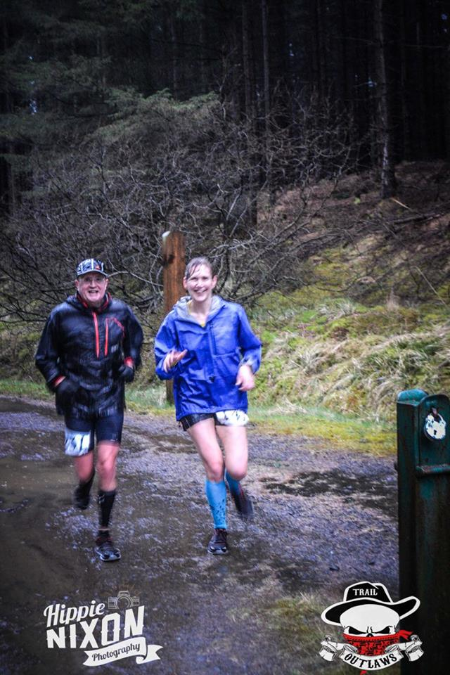
Still happy after about 5 miles.

It started to get really dark after about 14 miles, which was around 7p.m., and so the headtorches came out.
Everything changed then. Our world was reduced to little circles of light a few feet in front of us and the physical and mental concentration required was considerable.
Progress became much slower and we were pleased to reach the drinks station at the north end of the dam. The drink stations had water and coke and some sweets, with the occasional banana. Not a vast amount, but it was enough. The water was a bit tricky to drink quickly as it was very cold, so all credit to the excellent and enthusiastic helpers throughout the event, who must have been cold too.
There was a nice run over the dam where there was no need to be careful about footing before getting back onto the trail on the south side at about 17 miles.
I had a difficult spell shortly after this, mostly with the effort of staring at the ground where the torch beam landed. I gave myself a good talking to and was towed onwards by Melanie. I was able to reciprocate when she had a sickly spell in the last few miles.
The approach to Leaplish seemed to take forever. This was down on the course info as being at 24 miles (event distance was billed as 26.5). My Garmin had almost 25 miles showing, so we were almost cheerful as we set off on the last stretch.
We had our one wildlife encounter here on spotting a sheep just a few feet off the track. Its eyes were a spooky red colour in the light of a head torch. Despite the almost full moon, it had not turned into a slavering creature of the night, but just stood there placidly, eyes aglow.
Apart from Melanie then nearly falling into a ditch while trying to look at the stars, it was an uneventful trot to the end, although the final few yards were a puzzle as we had no idea where the end was.
I think we had assumed that it would be in the open area near the start.
It wasn’t.
We had to make a sharp left turn, then a right to end up back inside the activity room, to be surprised by a photographer.
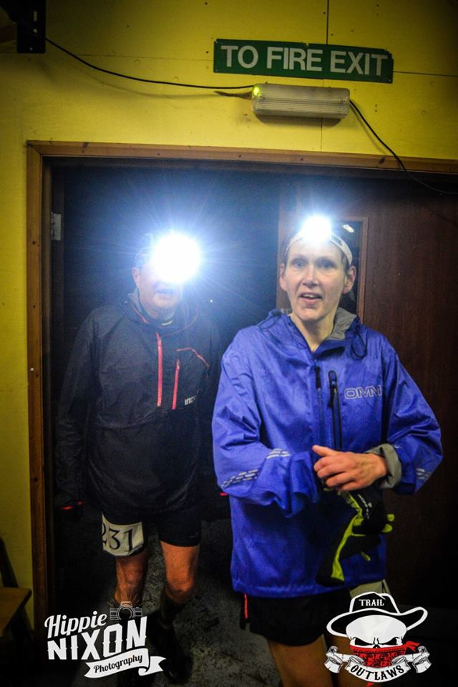
And here we are, surprised!

We managed a time of 4:34, despite being half way round in about 2 hours, which shows how hard we found the second half. Our positions were 57 and 58 out of 244 finishers. Not too shabby.
It was capped off by finding that I had won my age group as well.
There was tea and coffee and rice pudding at the end, but no cake.
It was a tough event in the second half and I think you need to be of a certain mentality to enjoy that type of thing.
I’m very pleased that I did the event, although I think that we will both be hanging up our head torches now and sticking to events run in daylight.

Ian Richardson
2 April 2016.

