Lanzarote International Marathon – 12 December 2015

The Canaries are named after dogs (from the Latin) not dicky birds, and they are windy.
That was pretty much the entirety of my knowledge of them before I went. Our group of five had originally looked at Malaga the week before, but that clashed with our own Hexham racecourse event, so there was no doubt as to which took precedence.
After a four and a quarter hour flight and a short taxi ride, we decamped to our hotel. This was a very pleasant place but a week all-inclusive is no good for someone with no will power.
That’ll be me then!
After a ten minute bus trip into Costa Teguise we made our way to the race HQ to pick up our numbers. There was a race limit of 300 for the full, and along with a half, 10k and 5k, about 1300 taking part in all.
The set up at the marathon start/finish, which was also the finish for all the other distances seemed quite extensive for a fairly small event.
Registration was painless and along with our number containing a chip, we received a goody bag which pretty much lived up to its name.
There was a very nice pale blue T shirt, a pair of socks, a soft rollable drinks holder, a huge bottle of sports drink and a few other bits and pieces, including a wrist band. #
Why do events do wrist bands?
That was that done and it was enjoying the place until the 8 a.m. start on Saturday.
As the only marathon runners in our group, George and I went for the 7:20 a.m. bus, which didn’t arrive, so we got a taxi along with a Spanish chap.
The start area was very relaxed with plenty of Portaloos and no queue to hand in bags. There was a
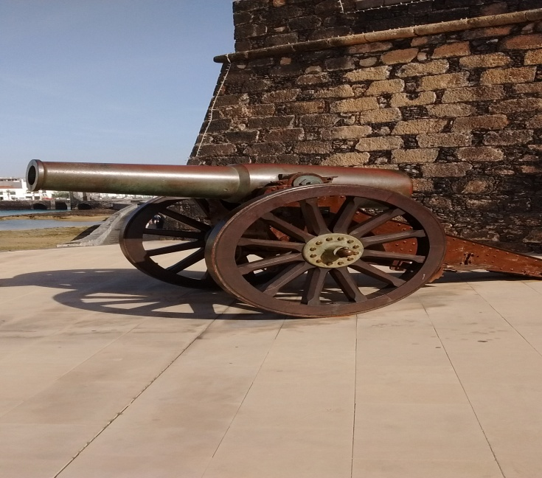
chance to catch up with a number of familiar faces, mostly from the 100 marathon club, then it was into the start area and away we went.
The course was very straightforward being 21k out along the coast, mostly on beachside paved paths, turn around and come back. There were also pacers for a variety of times.
Drinks stations were frequent and had water and isotonic drink in cups along with bananas and oranges.
Several drink stations also had water in bottles with sports caps, which was very useful as the day was very warm and there was no real breeze to speak of, despite the islands being known for wind.
The first k was through Costa Teguise, leading down to the coastal path when we started our long run along the seafront.
At about 3k I spotted a Durham Tri vest and started up a chat which lasted until about 29k. Its owner was Bruce Smith, brother of Stuart who does a lot of our races.
We left the coast path to go around the desalination plant which supplies a lot of the fresh water to this island which has very little rain. It’s not an attractive building, looking more like an oil refinery but it is vital.
We were then on the road until the capital, Arrecife, where we re-joined the coast path ad passed the local equivalent of Dunstanburgh castle.
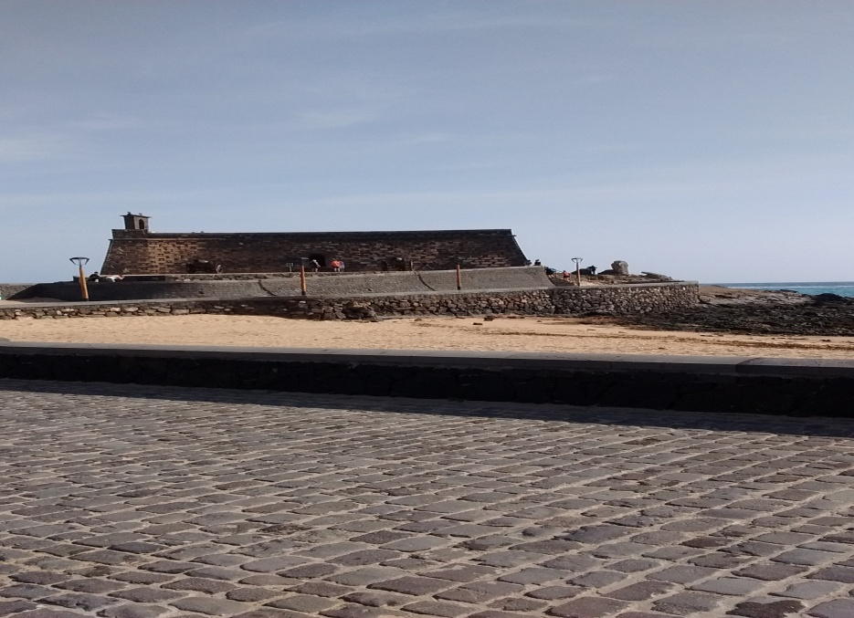

After that, it was on to Playa Honda, then to Puerto del Carmen and the turn around point.
Like our own coastal marathon, it was now a case of retracing our steps back to the start.
As my fourth marathon in four weeks, a sub four was looking assured and I was calculating what else might be possible.
With 10k to go, I realised that sub 3:50 might even be possible if I picked up the pace. This gave me a good target to aim at and I duly went for it.
The last coupe of miles involved a bit of weaving in amongst holiday strollers, but it was no real effort and there was much encouragement from them.
The overhead clock was still showing 3:48 as I was first able to focus on it, and I finished in 3:48:48 for my 25th marathon this year and 150th marathon overall.
It was not over yet, as there was a marvellous spread of food stuffs for us, which I sampled very fully indeed, having become really used to face stuffing from our time in the all inclusive hotel.
Two sorts of pasta, various fruits and nuts, biscuits of many sorts and that’s just what I can remember.
Oh yes, there was ice cream too, lollies and cornettos.
Still not finished, but giving the hideous and rather pointless alcohol free beer a miss, I made for the massage tent.
This was every bit as well organised as the rest of the event.
Firstly, in batches of 6-8, we were made to stand in a sort of paddling pool, over knee deep. This was for 5 minutes and if you didn’t last the course, you didn’t get your massage.
I made it and enjoyed a lovely going over for my legs, punctuated by some howling as my feet cramped up.
After getting changed and making sure that the food was still as good, it was, I saw that the results were already up ad that I was 4th out of 18 in my age group.
I then made my way to the grandstand to wait for George to come in.
During the wait, we learnt that out to 10k entrants, Janette and Sammy, had both won their age groups and would be part of the presentation which w to take place after the last runner came in.
This was George, who got probably the biggest cheer of the day as he played up to the crowd on his way in.
Within a couple of days, there were video clips available on line, one for each minute of finishing time, so you could see yourself shuffling to the end.
This was truly an excellent event. It had the feel and organisation of a much bigger event and I cannot praise it highly enough.
We will certainly be back and I can fully recommend it to anyone.

Ian Richardson
19 December 2015.

