

North East Marathon Club
Members Marathon 2014
The Leas, South Tyneside

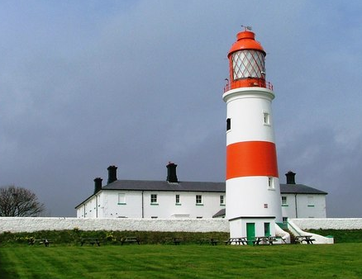

See
5 Lighthouses
1 Priory
1 Town Hall
1 Nature Reserve
All in
1 Marathon!

BASIC INSTRUCTIONS - YOU ARE ASKED TO CARRY THESE WITH YOU

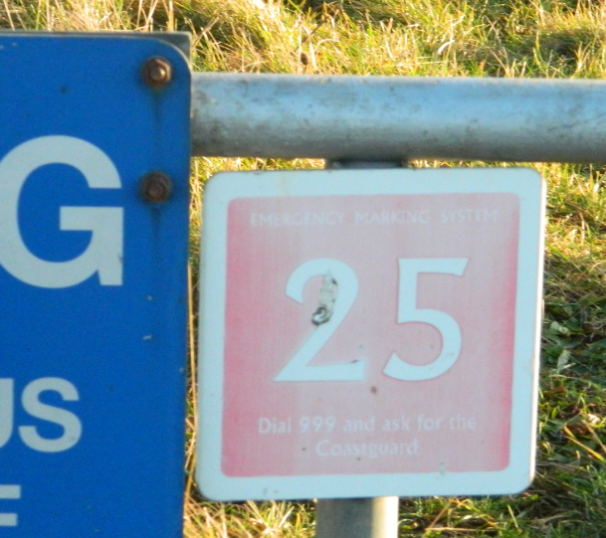
Keep following these markers

1 Start/Finish is next to the Water’s Edge pub

2 Follow the Coastal Path sign through the Trow Rocks quarry site as it climbs gradually up to the Leas, emerging at marker sign 25

3 Continue for approx. 2 miles on the obvious, yellow-clay surfaced Coastal Path as it skirts the coastline towards the Marsden Grotto, (Do not deviate from path on to any of the corner-cutting, short cuts!)

4 The path turns to the RIGHT as it approaches the cutting down to Marsden Beach. Follow it to Minchella’s ice-cream kiosk, across the cut and immediately back to the coast – reaching the cliffs at marker number 50.

5 Continue SOUTH through the Grotto car park towards Souter Point Lighthouse following the path closest to the cliffs past marker signs 64, 65 & 66

6 On reaching the now closed, car park after 66, turn immediate LEFT after entrance and run coastward alongside mesh fence on LEFT to resume the Coastal Path at marker 69

7 Continue heading south on obvious yellow path through gate to coastal side of Lighthouse, past marker 75

8 Take LEFT fork where paths divide at markers 81/82, continuing to marker 85

9 At 85 run up to wooden fence on RIGHT and run with fence on LEFT of you into Souter car park. Turn sharp RIGHT towards green bin and sharp right again to leave car park through gate past sign saying “Car Park closes 6pm”

10 You will connect with path you came up on. Now run back the way you came past the Grotto and Minchellas until just after sign for Camel Island – if you reach marker 47 you have gone too far!

11 Leave yellow path just before marker 47, turning LEFT and heading due NORTH on grass track with bushes on RIGHT to continue running through the middle of the Leas

12 On reaching green litter (dog waste) bin turn RIGHT back on to yellow Coastal path and follow back to marker sign 25 at top of quarry

13 Do not go down into quarry here, turn LEFT at Dog Waste Bin and follow all the way the along rim of quarry to eventually reach the road to the Waters Edge.. Descend on the grass to Start for end of first lap
REPEAT 3 MORE TIMES

NEMC MEMBERS MARATHON: THE LEAS, DETAILED ROUTE INSTRUCTIONS
Please familiarise yourself with these prior to the event.

1 Start is immediately outside the Water’s Edge pub

2 After a few metres, turn sharp LEFT to follow the Coastal Path sign through the Trow Rocks quarry site and on to path as it climbs gradually up to the Leas, emerging at marker sign 25
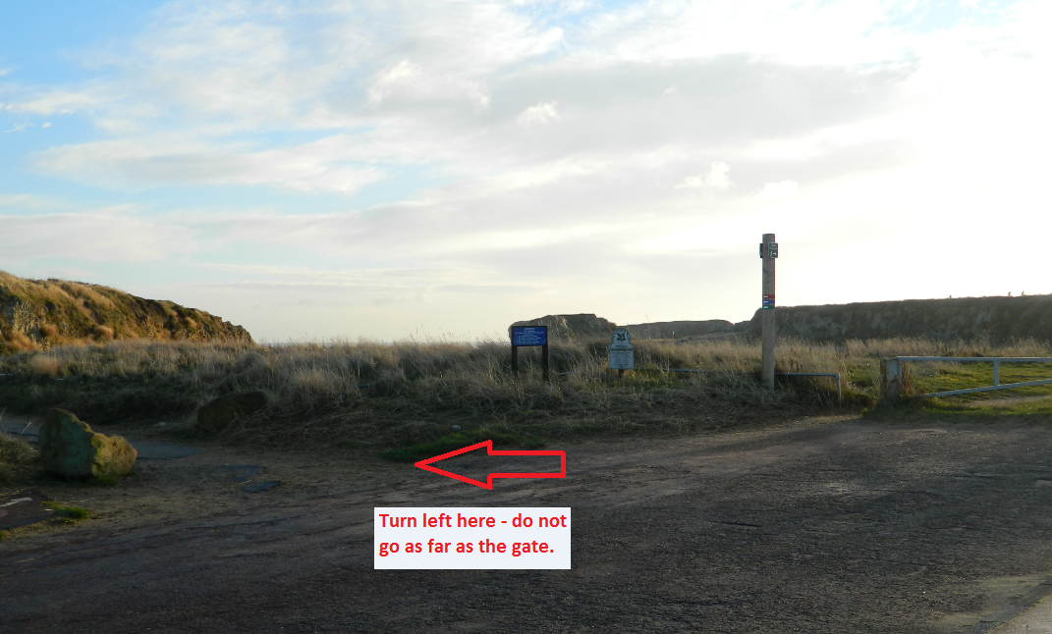

3 Continue for approx. 2 miles on the obvious, yellow-clay surfaced Coastal Path as it skirts the coastline towards the Marsden Grotto, (Do not deviate from path on to any of the corner-cutting, short cuts!)

4 The path turns to the RIGHT as it approaches the cutting down to Marsden Beach. Follow it to Minchella’s ice-cream building, across the cut and immediately back to the coast – reaching the cliffs at marker number 50.

5 Continue SOUTH through the Grotto car park towards Souter Point Lighthouse following the path closest to the cliffs past marker signs 64, 65 & 66

6 On reaching the now closed, car park after 66, turn immediate LEFT after entrance and run coastward with fence on LEFT to resume the Coastal Path at marker 69

7 Continue heading south through gate to coastal side of Lighthouse, past marker 75

8 Take LEFT fork where paths divide at marker 82, continuing to marker 85

9 At 85 run up to wooden fence and run with fence on LEFT into Souter car park and straight back out through gate past sign saying “Car Park closes 6pm”

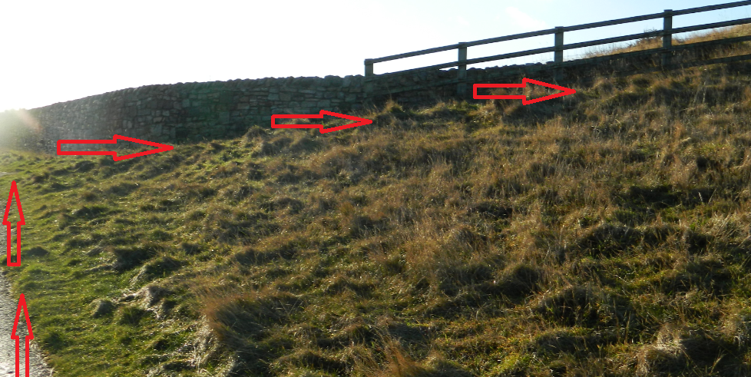

10 You will connect with path you came up on. Now run back the way you came past the Grotto and Minchellas until just after sign for Camel Island – if you reach marker 47 you have gone too far!
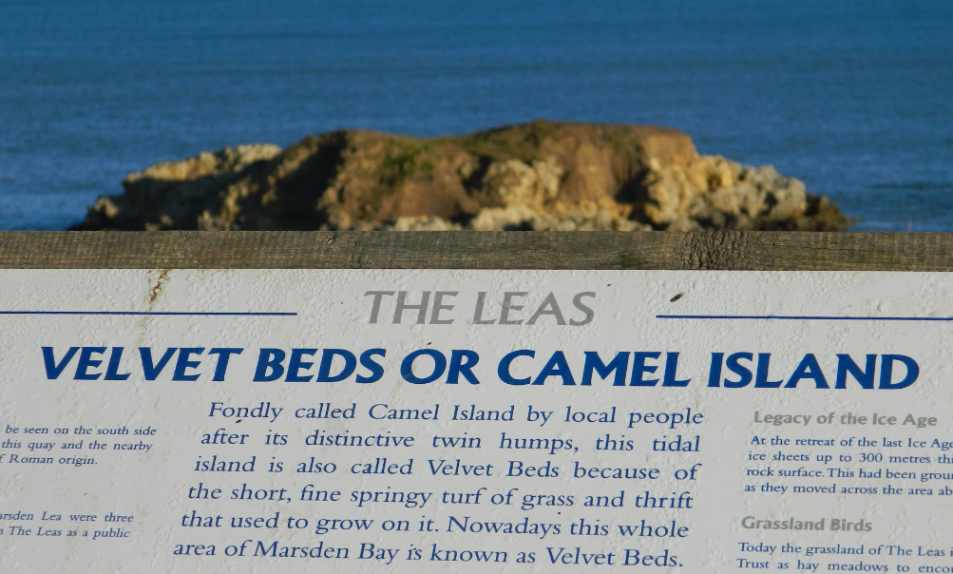

11 Leave yellow path here, turning LEFT and heading due NORTH on grass track with bushes on RIGHT to run through the middle of the Leas
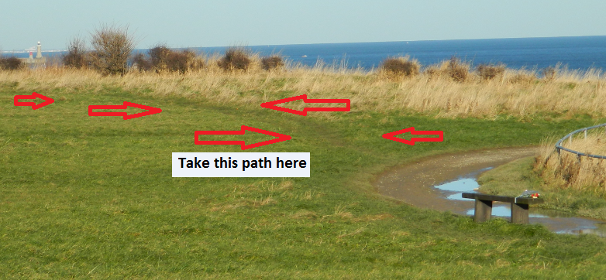
12 On reaching green litter (dog waste) bin turn RIGHT back on to yellow Coastal path and follow back to marker sign 25 at top of quarry

13 Do not go down into quarry here, turn LEFT and follow along rim of quarry to 2 more green litter bins standing together. Descend between these into the quarry and back to start for end of first lap

REPEAT 3 MORE TIMES

Profile of course

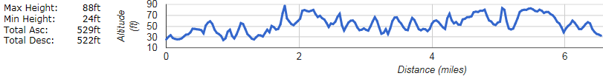

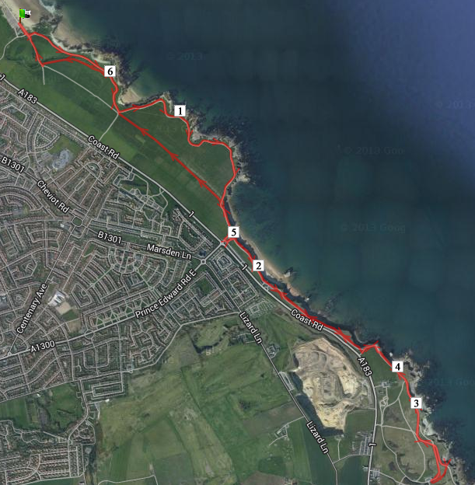

Part 1 Start to Marsden Beach
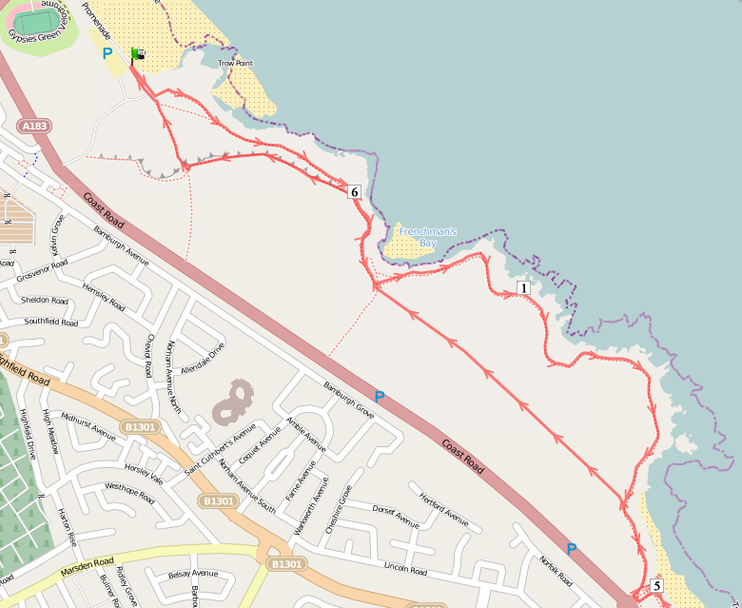

Part 2 Marsden Beach to Souter
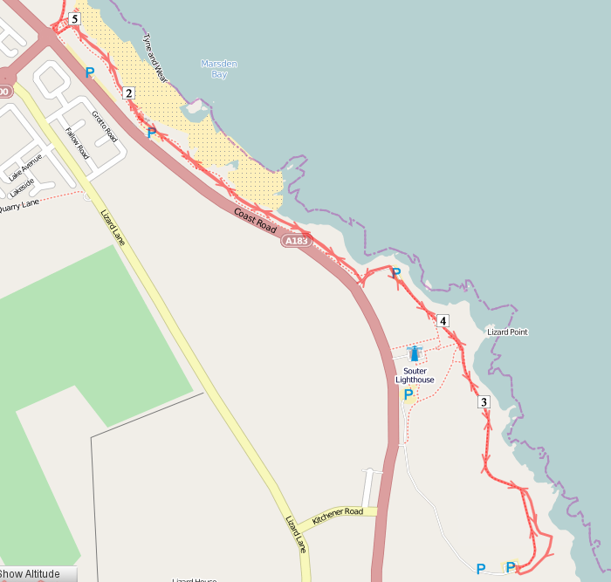

RISK | ASSESSMENT
PERSONS AT RISK CODES | MITIGATION CODES
A. COMPETITORS | 1. APPROACH SIGNS
B. SPECTATORS | 2. ROAD CLOSURE
C. ORGANISERS/MARSHALS | 3. MARSHAL
D. ONCOMING TRAFFIC | 4. ADDITIONAL MARSHALS
E. PASSING TRAFFIC | 5. SPECIAL MEASURE/SIGNAGE
F. TRAFFIC FROM RIGHT | 6. TRAFFIC CONES
G. TRAFFIC FROM LEFT | 7. DIRECTION SIGNS
 | 8. WRITTEN INSTRUCTIONS

LOCATION DESCRIPTION | NO. OF MARSHALLS | RISK LEVEL Low(L) Med. (M) High (H) | PERSONS AT RISK | MITIGATION TO REDUCE RISK TO LOW
START/FINISH | 2 | L | A,B | 3, 8
6. GROTTO CAR PARK: Now disused but may be used by walkers | 0 | L | A | 8
8. Missing car park turn | 0 | L | A | 7, 8
9. SOUTER CAR  PARK: Car park for National Trust property | 1 | M | A, B, F, G | 3, 8
5. Misdirection at grass section on route return | o | L | A | 7, 8
ENTIRE ROUTE: Deviating from path into sea | 0 | L | A | 8
ENTIRE ROUTE: General public and dogs on route | 0 | L | A,B | 8

