MALTA MARATHON 2015
Malta, or to give it its correct title Malta GC is an archipelago that we visited 15 years ago. The first major change on arriving at the airport is that the old green boneshaker buses have all gone. We later find that grown men cried when they were decommissioned but the journey back to Sliema is now a little smoother, albeit you still need to change at Valletta. We arrive on the Friday, get settled and walk towards the registration hotel at nearby St Julien’s. The hotel is not well signposted and on enquiring at a shop, we are the 5th people to ask for directions in the last five minutes. We arrive at the hotel and make for the lift. The doors are closing, so we do the usual thing and dive in. There are no buttons to press and the lady inside advises that we have to go to her floor, get out and press the floor number from the outside – different! 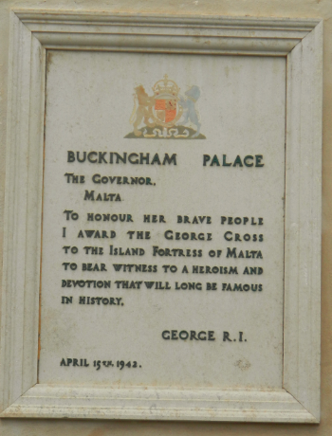
We arrive at our destination and the queue is massive, we wait around an hour to be shown (in groups of 5 or 6) into a room which is not much bigger than our hotel bedroom. I then discover why I don’t know my number yet. They simply give you the next available number and record the information on their computer. We get our kitbag (black bin liner), a cereal bar, a couple of leaflets, a cotton t-shirt (yes, cotton!!) and the opportunity to buy a better quality one for 15 Euros! We pass on that one. Leaving the reception room the queue has died down a little, but I suspect that it will be 45 minutes before it completely clear.
On the Saturday, we visit some friends/honorary Aunt/Uncle of Christine’s in Naxxar to reminisce and put the world to rights for the day. The beauty of this arrangement is that I’m sitting for seven hours – perfect preparation without wasting the day.

The race is a 7.30 start, with buses taking us to the ancient Roman Capital of Mdina at 6am.
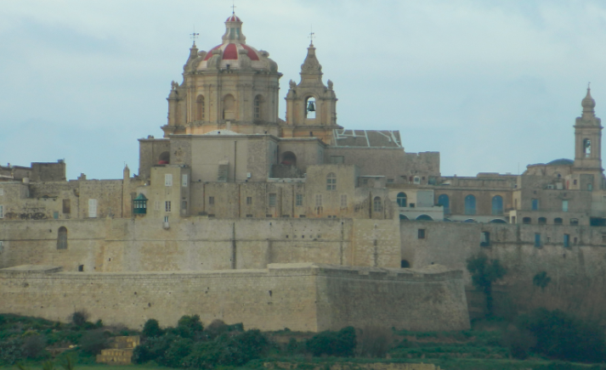
The hotel has put on breakfast at 5, so I’m able to grab a couple of slices of toast before walking across the road. The finish line is on the other side of the road from the hotel – how’s that for planning?
Earlier in the week, there was a 40% chance of thunderstorms during the race. It then reduced to 35%. It’s still cold and windy, but we’re told that there is now a zero% chance of rain. I love it when the experts make their mind up! Before we left, our friends told us that the weather was terrible and to take plenty of clothing/waterproofs.

The course suffered as a result with lots of surface standing water and the potholes kindly collected the rain water to alleviate the inadequacy of the drains!

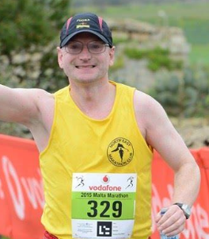

The first 26k are in and around the central region of the island, passing the ancient city a few times and allowing 4 different views of the renowned Mosta Dome. There is a half marathon starting at 9.15 and we join their route at the 5k mark and run the final 16k together. The good news is that I reach the 26k mark after most of the runners have gone through. Unfortunately there is also a 21.1k Walkathon starting behind the half marathon. Most of which have arrived at the 5k mark before I join the course, so I’m contending with 2 or more people walking side by side without a care in the world taking in the scenery, stopping for selfies, slowing down to gingerly bypass a flooded pothole and totally oblivious that someone Is trying to get past them.
I appreciate that some races need to have multi-events to make them financially viable, but this is not the greatest idea in the universe. Most people know that I have a long association with Edinburgh, having run the event every year since its inception with the exception of 2012, that event is no longer marathon friendly since the inception of the half. Malta suffers from a similar problem if you are not fast enough to get to 26k before the walkathon athletes get to 5k. Whilst the weather forecasters were hedging their bets as to what percentage chance of thunderstorms would hamper the race, the rain still hit with a vengeance. It didn’t last long but there were a couple of heavy showers.
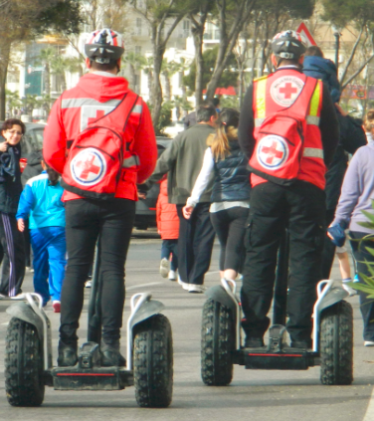
There are a few hills during the first half of the race, but the majority of the second half is flat/downhill and this allows me to knock 20 minutes off my time at Malaga in December. As I approach the finish a couple of guys on segways approach me. I mumble something unrepeatable about them getting out of my way, when I discover that they are in fact Red Cross guys and they checked up on every finisher to ensure that no medical treatment was required at the end. Having never had any desire to use one, it strikes me that they’re more likely to be treating each other than the runners! I finish the race, get my kit bag and cross the road to the hotel to look out of the balcony to discover that the heavens have opened again.
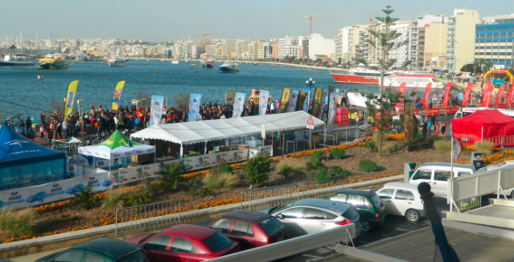
On the Monday we did a little bit of sightseeing before heading back home via Amsterdam to celebrate our Pearl Anniversary with a performance of Bizet’s Pearlfishers.
Would I do it again? This is the 30th Malta Marathon, The actual number of runners in the marathon was in the hundred’s rather than the thousands, so it probably needs the half to make it viable. I like the split start, which doesn’t impede the marathon runners…. Or at least it doesn’t impede the slower marathon runners. However, unless I return to my former fitness, I wouldn’t do it whilst the walkathon was on. Registration needs to be improved. Transport to the start was good and the baggage reclaim was fine. The island is well worth the visit, so if you’ve never been and are looking for an excuse – go for it. Unfortunately I’d need to be fitter or have the knowledge that the walkathon has been cancelled and that registration is much better than it is. On the plus side, cycles are banned and anyone receiving assistance from a cycle would be liable to disqualification. Some of our UK marathons could, after all, learn something from Malta.
