MELBOURNE MARATHON October 12 2014

Melbourne is Australia’s largest marathon and one I was particularly looking forward to as it involved an eagerly anticipated pilgrimage to one of the world’s greatest sporting arena: the mighty MCG, home of both Australian cricket and Australian Rules Football. I’d been a regular spectator at both sports during my 15 years living in the country. Only two weeks earlier I’d enjoyed watching this year’s Rules Grand Final between Hawthorn and Sydney at the “G” - with over 99,000 spectators filling the ground. Melbournites truly love their sport! The Expo held there, unlike that in Sydney, was well worth going to with a variety of interesting exhibits on show. We were handed a re-usable event shoulder bag, (the Aussie’s call them show bags, not goody bags), containing hat, towel and truly awful T-Shirt.
I was also looking forward to catching up with some of the members of the Australian 100 Marathon Club I’d met on my visit here, having been invited by Chairman Bob Fickel to the Club’s post-race function at a Richmond Hotel. With only 45 members, the Club is the epitome of Aussie sociability and while they take their running (but not themselves) seriously, their emphasis is heavily on the social side of marathon-running. I felt at home in their company and, holding Aussie citizenship, intend to join their Club if only to complete their “Australian Sweep” – a marathon in each of the 6 States and 2 Territories.
The 37th edition of the race started at sunrise outside the Rod Laver Arena where the annual Australian Open Tennis Championships take place. A special section of the Start is reserved for the Melbourne Marathon Spartans: runners who have completed the majority of the marathons. Different coloured running vests are awarded for those who’ve done 15, 20, 30, 35 and 37 races. The Marathon with 7,400 entrants was the first of 5 events incorporating 32,000 runners to take place that morning. (10,000 in the Half and 7,000 in the 10k) A few words of encouragement from local marathon legend Steve Moneghetti preceded a rousing version of the National Anthem before we set off into the Australian dawn for a tour of the city and its beach suburbs. I don’t mean to keep banging on about temperatures – Australia is, after all, synonymous with hot weather – but the day’s forecast was for 30 degrees. Knowing that it was important to make the most of the first couple of hours before the sun began to bite, I started this one at a slightly faster pace than normal, knowing I had little hope of keeping it up.

The Spartans tent outside the MCG
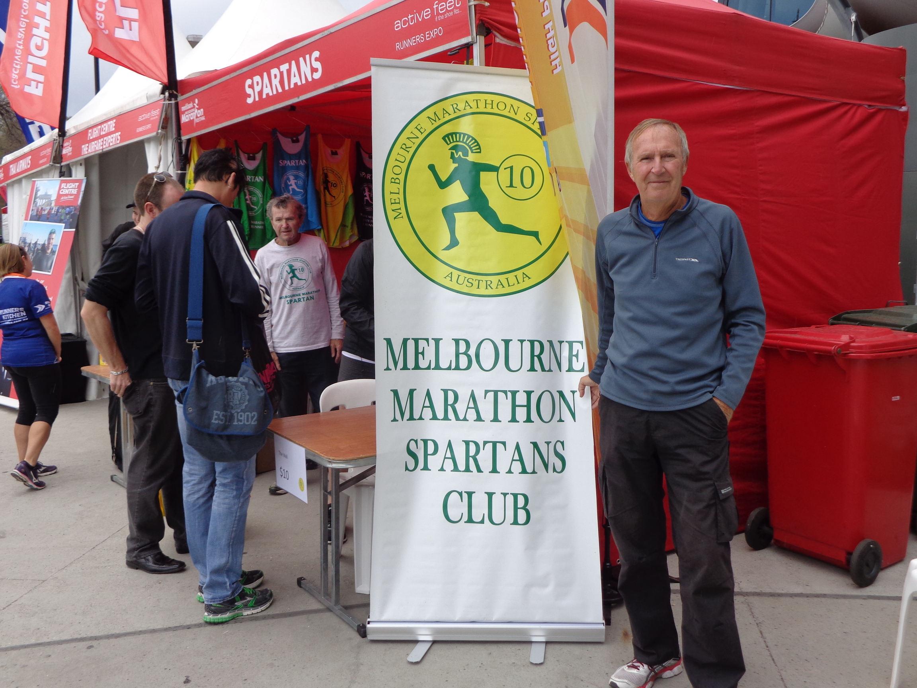

The first kilometre or so was slightly uphill before things evened out on historic Flinders Street. The next 4km took us arrow-straight south along the broad St Kilda Road, before turning towards the coast and into the city’s huge Albert Park – home to Australia’s Formula One Motor Race. For the next 10km we lapped the giant lake within the park: turning back on ourselves on more than one occasion to see those ahead and behind us in the race. A short section down the trendy Fitzroy Street brought us to the St Kilda seafront at 16km. Then followed a 14km, flat out and back section along the Esplanade, with excellent ocean views of Port Phillip Bay and just the hint of a breeze. This didn’t last long, however, and at 30km we turned inland into the heat of the sun as we returned towards the city skyline, back along St Kilda Road. The 35km mark brought another loop through an underpass to emerge into Melbourne’s beautiful Botanical Gardens. The course followed an undulating route through the Gardens with some welcome tree-shade until, finally, we were back among the cheering crowds on Flinders Street with less than 2km to go. A sharp turn soon had us staring uphill at the magnificent MCG and the finish gantry on the main concourse. What an iconic place to finish a marathon – though at this stage it was sheer pandemonium with runners from various events appearing to be finishing at the same time, encouraged by hordes of screaming supporters. Two of our great friends from way back had made the long journey from Western Australia to spend time with us in Melbourne and had managed to position themselves at the finish line as I arrived. I was delighted to see them and quite satisfied with a 4hr 18 minute finish in the heat. The large medal more than compensated for the ugly T-Shirt.

Not a bad medal!
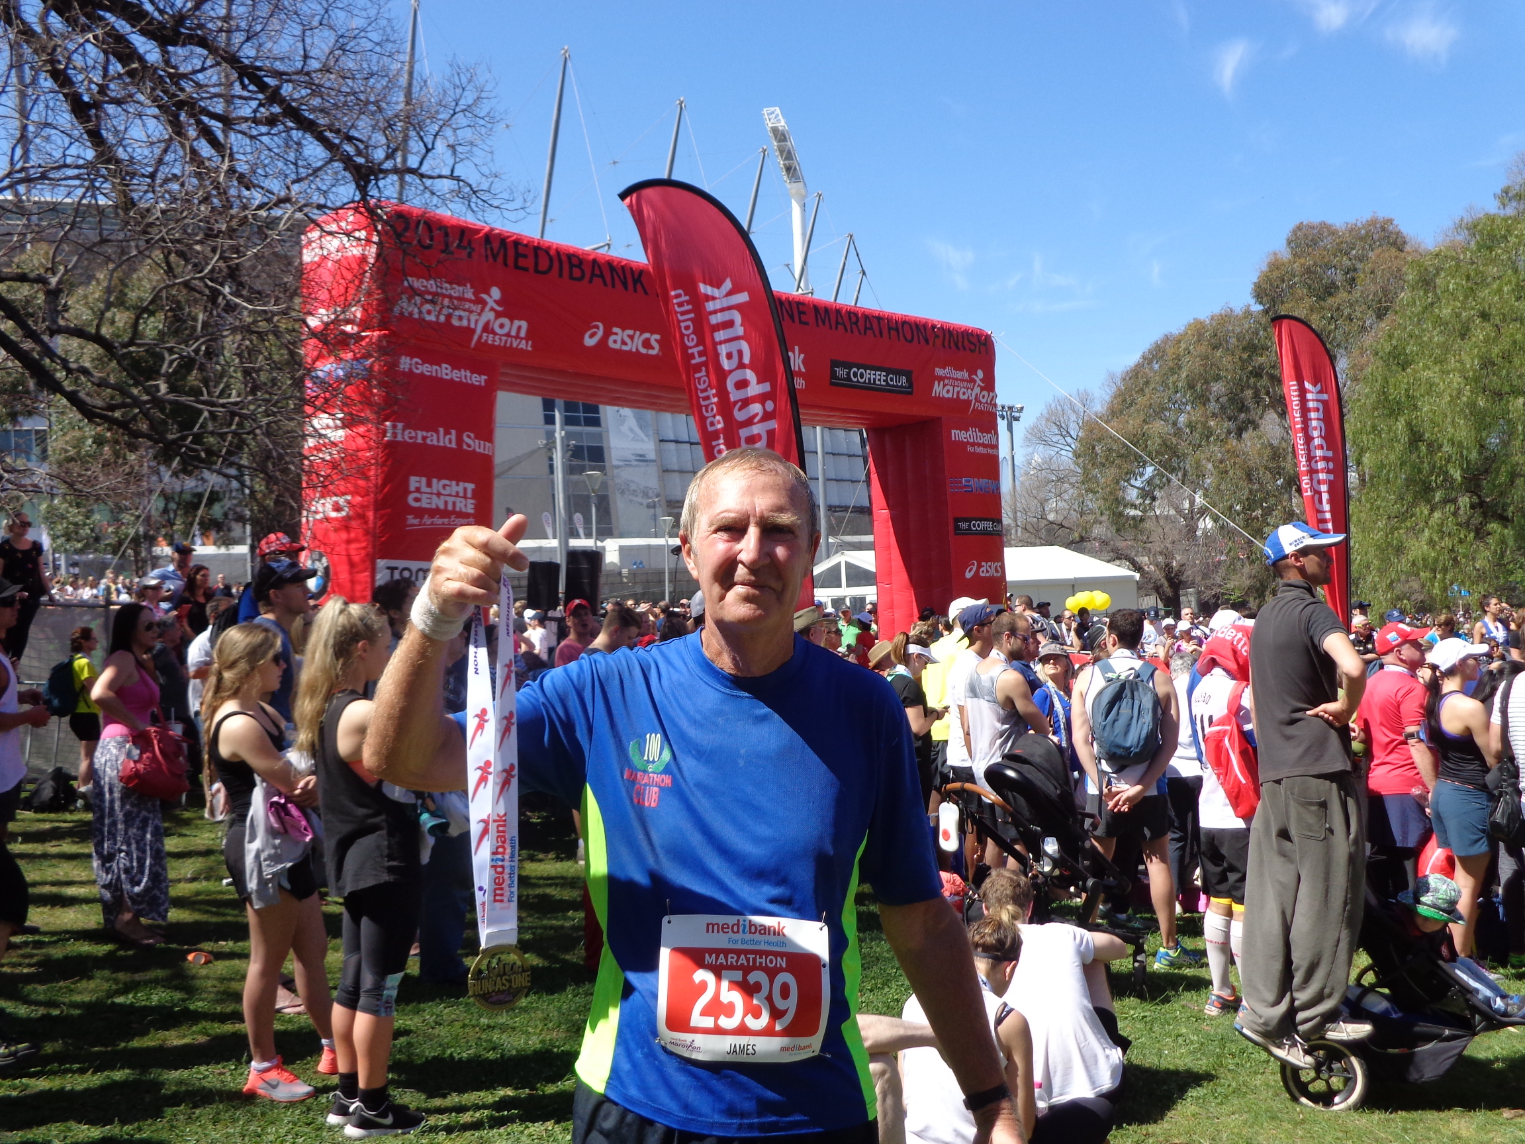

Melbourne was not as scenic as Sydney had been three weeks earlier, nor did it take us past as many historic and iconic parts of the city. There were also too many out-and-back sections watching runners in the opposite direction to make it as interesting a marathon as that of its big city rival. Nonetheless, it was an efficiently organised, thoroughly enjoyable event providing another excellent day out in the sun. I’d happily do it again.

Jim Manford
October 15th 2014

