Winter Railway Ultra - Shropshire – 21 Feb 2015-02-22

Winter isn’t the easiest time to find good events in the UK, so it was a very long trip to Coalport, near Telford for this event.

It was organised by Denzil of codrc.co.uk, who also puts on the Groundhog track marathon, that Jim and I did, two years ago.

This event consists of out and backs on a disused railway heading towards Bridgnorth, each section being about 4.7 miles.
There was a drinks station at the turnaround point and at the lap start/finish, which also had nibbles.
The event had 9Bar sponsorship and their rather lovely products were available at both drinks stations.

You could opt for either 3 or 4 laps and make your mind up as you were running. It had always been my intention to do 4 laps, for a total of nearly 38 miles, which would make it my longest run to date.

I had stayed overnight about a mile away in a pub with rooms and left the car there on the Saturday morning. It wasn’t very practical to get very much closer, so there was a good walk before and after the event.

The 78 of us gathered on the old railway line, behind the Woodbridge Inn.
It was all pleasantly low key as we registered under a garden type gazebo, which was also the feed station.
I had the chance to say hello to a number of supporters of our NEMC events, including Bill and Pauline Howes, who I hadn’t seen for a little while.
After a bit of chatting to people, we were gathered for a group photo and then sent on our way.

The course itself was quite varied and mostly followed the nearby river. Conditions under foot went from tarmac to gravel and some muddy bits. It was all perfectly suited to road shoes. The most awkward part was the camber, or lean, on parts of the course, which had runners looking for the least inclined part each time we reached such a section.

There were a few homes along the route so the occasional vehicle had to be watched out for, but they all travelled slowly and were respectful of the runners.

At roughly half way there was a home that used to be Linley station. It looked very good, but did make me wonder what the catchment area for such a location must have been.
I ran the first lap with a friend and surprised myself by running at sub 9 min/mile, which I knew I would be unable to sustain.

An upset stomach caused me to stop to use the handily sited portaloo, of which more later!, and thereafter I ran on my own at a rather more sedate pace.

The second lap seemed a real struggle and for no obvious reason, so at the turnaround point I broke out the ipod and gained some inspiration from a fine set of tunes.
Still not happy after the end of the lap, I began to contemplate just doing the three laps, for an approximate 28 miles.
Again for no obvious reason I started to feel better and ran the third lap feeling much more comfortable. I had noted the half marathon distance being covered in 2 hours and then the marathon distance in 4:02, so that cheered me considerably too.

As I closed in on the end of the third lap, I was asked if I was going out again and had (almost) no hesitation in saying yes. For some reason, at the end of each lap we were given a coloured bracelet to wear to indicate how many laps we had done. Given the numbers of runners involved, I’m not sure why this was done.
I completed the third lap in 4:31, so was hopeful of finishing the fourth lap inside 6:30, even allowing for dramatic slowing.

I started off quite well, but mental and physical fatigue made me have my first walk by the station, about half way into the last out section. That sufficed to the turnaround point, but the last back section nearly saw me off.

I think it was every bit as much mental as physical and I had a number of little walks, whilst berating myself for doing so.
The end of the course was around a bend and the first indication of it, for me, was the sight of the white roof of the portaloo. I knew then that I had only a few hundred yards to go, so roused myself from a trot into a proper run.

You would think I’d know better by now!

There was no one in front or behind me, but there I was, galloping to the end.

On crossing the (imaginary) line, and having my number recorded, I bent over to put my hands on my thighs, and bang, got an astonishingly agonising cramp in my right hamstring.

I couldn’t straighten my right leg, so had to waddle over to a box for a sit down. An impressive finish, I’m sure you will agree. It certainly attracted attention.
I was fine after that and was given my rather nice medal.

This was all topped off, when, after putting on dry top and jacket, I was presented with a spot prize. I can’t remember when I last had one of those. It was a very nice 9Bar branded pocket LED torch.

Time was 6:16:30. I was very happy with that and appear to be largely undamaged, just very very tired.
A really pleasant low key event that has given me confidence for stuff a bit longer than a marathon.

Ian Richardson
23 Feb. 15

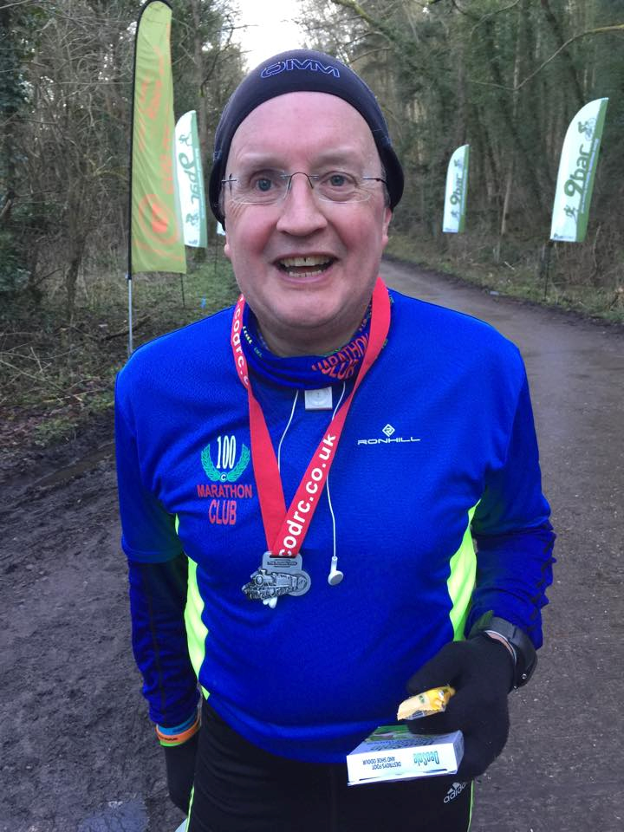
Still in pain with cramped hamstring!

